Fresno County Rural Transit Agency’s

Title VI Program

UPDATE 2026-2029

This document was prepared by the Fresno County Rural Transit Agency (FCRTA) and approved by its Board of Directors to further comply with Title VI of the Civil Rights Act of 1964, including new provisions detailed in United States Department of Transportation’s Federal Transit Administration Circular 4702.1B, “Title VI Requirements and Guidelines for Federal Transit Administration Recipients”.

Adopted: June 25, 2026
(Resolution No. 2026-02)

Prepared by:
Fresno County Rural Transit Agency
2035 Tulare Street, Suite 201
Fresno, CA 93721
(559) 233-6789
Fresno County Rural Transit Agency’s

Title VI Program

Board of Directors:
Mayor Nathan Vosburg, City of Coalinga
Mayor Freddy Valdez, City of Firebaugh
Mayor Juan Mejia, City of Fowler,
Mayor Ray Leon, City of Huron
Mayor Maria Pacheco, City of Kerman
Mayor Pro Tem Brandon Pursell, City of Kingsburg, Vice Chair
Mayor Victor Martinez, City of Mendota, Chair
Mayor Gilbert Garcia, City of Orange Cove
Mayor Alma Beltran, City of Parlier
Mayor Matthew Tuttle, City of Reedley
Mayor Frank Gonzalez, City of Sanger
Mayor Adam Flores, City of San Joaquin
Mayor Scott Robertson, City of Selma,
Supervisor Gary Bredefeld, County of Fresno

Staff:
Janelle Del Campo, General Manager
Emily Flores, Operations & Planning Manager
Jennifer Rodriguez, Staff Analyst
Gilbert Garza, Senior Transit Planner
Denise Flores, FCRTA Office Manager
Long Her, Accounting Manager

Legal Counsel:
Alison Samarin, Deputy County Counsel
SECTION 1:

PROGRAM POLICY AND COMPLAINT PROCEDURES

POLICY

The Fresno County Rural Transit Agency (FCRTA) is committed to ensuring that no person is excluded from participation in, denied the benefits of, or otherwise subjected to discrimination under any of its programs, activities, or services on the basis of race, color or national origin. All persons, regardless of their citizenship, are covered under this regulation. In addition, Fresno County Rural Transit Agency prohibits discrimination on the basis of race, color or national origin in its employment and business opportunities.

Fresno County Rural Transit Agency will continue to not condone retaliation against an individual for his/her involvement in asserting his/her rights pursuant to Title VI or because he/she filed a complaint or participated in an investigation under Title VI, and /or this regulation.

As a Federal Transit Administration (FTA) fund recipient, Fresno County Rural Transit Agency will continue to ensure that its programs, policies and activities comply with the Department of Transportation (DOT) Title VI Regulations of the Civil Rights Act of 1964.

Fresno County Rural Transit Agency will continue to ensure that the level and quality of its transportation service is provided without regard to race, color or national origin.

Fresno County Rural Transit Agency will continue to promote the full and fair participation of all affected populations in the transportation decision-making process.

Fresno County Rural Transit Agency will continue to make good faith efforts to achieve environmental justice as part of its mission by identifying and addressing, as appropriate, disproportionately high and adverse human health or environmental effects of its programs, activities, and services on minority populations and low-income populations within Fresno County Rural Transit Agency's service area as provided herein.

Fresno County Rural Transit Agency will continue to ensure that Limited English Proficient (LEP) individuals have access to Fresno County Rural Transit Agency's programs, activities, and services.

The Fresno County Rural Transit Agency’s Title VI Policy will continue to be posted on the agency website, within the administrative offices, within vehicles and at high demand stops throughout the system.

This Regulation shall be maintained in English and Spanish.

POLICY DISTRIBUTION

FCRTA’s Title VI Policy is distributed in a variety of ways and as by proscribed by Title VI Regulations. The following is a list of locations where the Title VI public notice is posted:
- FCRTA’s website at www.ruraltransit.org
- Public areas including the FCRTA administrative office reception desk and meeting rooms; City Hall offices reception desk in the Cities of Firebaugh, Mendota, San Joaquin, Kerman, Huron, Coalinga, Fowler, Selma, Kingsburg, Sanger, Parlier, Reedley, and Orange Cove.
- FCRTA bus stops located in the Cities of Fresno, Firebaugh, Mendota, Kerman, Fowler, Selma, Kingsburg, Sanger, Parlier, Reedley, Orange Cove, Huron, and Coalinga.
- On all FCRTA transit vehicles.

APPLICABILITY

This policy is applicable to all Fresno County Rural Transit Agency employees, members of the public and all contractors hired by Fresno County Rural Transit Agency. Failure of an Fresno County Rural Transit Agency employee to follow this policy and procedure may subject such employee to disciplinary action up to and including employment termination.

DEFINITIONS

Adverse Effect means having a harmful or undesired effect.

Discrimination refers to any act or inaction, whether intentional or unintentional, in any program or activity of a Federal aid recipient, subrecipient, or contractor that results in disparate treatment, disparate impact, or perpetuates the effects of prior discrimination based on race, color, or national origin.

Limited English Proficient (LEP) Persons are individuals for whom English is not their primary language and who have a limited ability to speak, understand, read, or write English. It includes people who reported to the U.S. Census that they do not speak English well or do not speak English at all.

Low-Income Population means any readily identifiable groups of low-income individuals who live in geographic proximity, and if circumstances warrant, geographically dispersed transient persons (such as migrant workers or Native Americans) who will continue to be similarly affected by a proposed DOT program, policy, or activity.

Minority Individuals

1. American Indian and Alaska Native, which refers to people having origins in any of the original peoples of North and South America (including Central America), and who maintain tribal affiliation or community attachment.

2. Asian, which refers to people having origins in any of the original peoples of the Far East, Southeast Asia, or the Indian subcontinent.
3. Black or African American, which refers to people having origins in any of the Black racial groups of Africa

4. Hispanic or Latino, which includes people of Cuban, Mexican, Puerto Rican, South or Central American, or other Spanish culture or origin, regardless of race.

5. Native Hawaiian and Other Pacific Islanders, which refers to people having origins in any of the original people of Hawaii, Guam, Samoa, or other Pacific Islands.

National Origin means the particular nation in which a person was born, or where the person's parents or ancestors were born.

Race means a group of people united or classified together on the basis of common history, nationality, or geographic distribution.
Recipient means one that has received or is receiving Federal financial assistance. The term includes subrecipients of a recipient and subrecipients in FTA State administered programs.
Retaliation Any adverse action taken against another individual because of his/her participation in the complaint, investigation, or hearing relating to this policy or the provision of federal or
State law.

Vital Documents are documents that convey information that critically affects the ability of the customer to make informed decisions about his/her participation in the program (e.g., public notices, consent forms, complaint forms, eligibility rules, notices pertaining to the reduction, denial or termination of services or benefits, right to appeal, and notices informing customers of the availability of free language assistance).

GENERAL REQUIREMENTS AND GUIDELINES

Fresno County Rural Transit Agency will continue to carry out its programs, activities, and services in compliance with Title VI of the Civil Rights Act of 1964. Fresno County Rural Transit Agency or any of its employees will continue to not, on the grounds of race, color, national origin, age, sex, sexual orientation, or gender identity, exclude any person from participating in, deny the benefits of, or subject him/her to discrimination under any Fresno County Rural Transit Agency programs, services, or activities.

Fresno County Rural Transit Agency nor any of its employees will continue to not, on the grounds of race, color or national origin:

1. Provide any service, financial aid, or benefit that is different from that provided to other;

2. Subject an individual to segregation or separate treatments;

3. Restrict an individual in the enjoyment of any advantage or privilege enjoyed by others;
4. Deny any individual service, financial aid, or benefits under any Fresno County Rural Transit Agency programs, services, or activities;
5. Treat individuals differently in terms of whether they satisfy admission or eligibility requirements; and
6. Deny an individual the opportunity to participate as a member of a planning or advisory body.
Fresno County Rural Transit Agency shall evaluate significant system-wide service and fare changes and proposed improvements at the planning and programming stages to determine whether these changes have a discriminatory impact on low-income and Limited English Proficiency individuals. This applies to major service changes that affect 25% of service hours of a route.
Fresno County Rural Transit Agency schedules at least one Board Meeting every month to ensure that all individuals are afforded an opportunity to participate in transportation decisions.
Fresno County Rural Transit Agency's legal counsel will continue to maintain a list (a minimum of four years in active status) of any Title VI investigations, complaints, or lawsuits filed which allege Fresno County Rural Transit Agency discriminated against a person or group on the basis of race, color, or national origin. This list continues to include:
1. The date the complaint, investigation, or lawsuit was filed;
2. A summary of the allegation(s);
3. The status of the complaint, investigation, or lawsuit; and
4. Any actions, or corrective actions, taken by Fresno County Rural Transit Agency in response to the complaint, investigation, or lawsuit.
Fresno County Rural Transit Agency will continue to keep the public informed of the protections against discrimination afforded to them by Title VI and Fresno County Rural Transit Agency's obligations under Title VI by posting a Title VI Policy Statement (Attachment A) in English, Spanish, Arabic, Tagalog, Vietnamese, and Chinese and associated Complaint Forms, in these six languages on Fresno County Rural Transit Agency's website at www.ruraltransit.com, at the Fresno County Rural Transit Agency administrative offices, at FCRTA-member agency City Halls, at high-use FCRTA bus stop shelters, and on FCRTA vehicles.
Fresno County Rural Transit Agency will continue to take responsible steps to ensure meaningful access to the benefits, services, information and other important portions of its programs, activities and services for individuals who are Limited English Proficient (LEP).
Fresno County Rural Transit Agency will continue to provide information, upon request from FTA, in order to investigate complaints of discrimination, or to resolve concerns about possible noncompliance with Title VI.
Fresno County Rural Transit Agency will continue to submit its Title VI Program to the PTA's regional civil rights officer once every three (3) years to ensure compliance with Title VI Requirements.
Fresno County Rural Transit Agency will continue to ensure that minority and low-income individuals have meaningful access to Fresno County Rural Transit Agency programs, activities and services.

ENVIRONMENTAL JUSTICE REQUIREMENTS
Fresno County Rural Transit Agency will continue to integrate an environmental justice analysis into its National Environmental Protection Act (NEPA) documentation of construction projects. Fresno County Rural Transit Agency is not required to conduct environmental justice analyses of projects where NEPA documentation is not required. Fresno County Rural Transit Agency will continue to consider preparing an environmental assessment (EA) or environmental impact Statement (EIS) to integrate into its documents the following components:
- A description of the low-income and minority population within the study area affected by the project, and a discussion of the method used to identify this population (e.g., analysis of Census data, direct observation, or a public involvement process);
2. A discussion of all adverse effects of the project both during and after construction that would affect the identified minority and low-income populations;
3. A discussion of all positive effects of the project that would affect the identified minority and low-income populations, such as improvements in transit service, mobility, or accessibility;
4. A description of all mitigation and environmental enhancement actions incorporated into the project to address the adverse effects, including, but not limited to, any special features of the relocation program that go beyond the requirements of the Uniform Relocation Act and address adverse community effects such as separation or cohesion issues; and the replacement of the community resources destroyed by the project;
5. A discussion of the remaining effects, if any, and why further mitigation is not proposed; and
6. For projects that traverse predominantly minority and low-income and predominantly non-minority and non-low-income areas, a comparison of mitigation and environmental enhancement actions that affect predominantly low-income and minority areas with mitigation implemented in predominantly non-minority or non-low-income areas.
LIMITED ENGLISH PROFICIENT (LEP) INDIVIDUALS AND PUBLIC PARTICIPATION REQUIREMENTS
Fresno County Rural Transit Agency will continue to seek out and consider the viewpoints of minority, low-income and Limited English Proficient (LEP) populations in the course of conducting public outreach and involvement activities. Fresno County Rural Transit Agency's public participation strategy will continue to offer early and continuous opportunities for the public to be involved in the identification of social, economic and environmental impacts of proposed transportation decisions.
Fresno County Rural Transit Agency will continue to ensure that individuals have access to its programs, activities and services by developing and carrying out the language plan herein. Fresno County Rural Transit Agency will continue to continually assess the language assistance needs of the population to be served.
Fresno County Rural Transit Agency will continue to use the following four (4) factors to determine what measures must be undertaken to provide reasonable and meaningful access to LEP individuals.
1. Languages likely to be encountered and the number or proportion of LEP persons in the eligible service population likely to be affected by the program, activity, or service.
2. Frequency with which LEP individuals come into contact with Fresno County Rural Transit Agency programs, activities, and services.
3. Importance of the program, activity, or service provided by Fresno County Rural Transit Agency to LEP individual's lives.
4. Resources needed to provide effective language assistance and costs.
ORAL LANGUAGE ASSISTANCE
Fresno County Rural Transit Agency will continue to make every effort to employ bilingual staff to provide Spanish-speaking interpretation at its Administrative office and within its Customer Service for basis transit questions and trip planning assistance.
OUTREACH PLAN
Outreach Plan to Engage Minority, Low-Income, and LEP Populations: Fresno County Rural Transit Agency will provide for a public participation process in its planning and decision-making processes. The public participation process will be considered at the earliest stages of any FCRTA transit project or decision that may impact the surrounding community, FCRTA riders, or potential riders. Project specific outreach efforts will be tailored to the populations affected and the type of plan, project, or service under consideration.

FCRTA maintains contacts with local social service providers, non-profit organizations, advocacy groups, and public agencies that provide assistance to minority, low-income, and LEP clients. Such non-profits, social service providers, advocacy groups, and agencies have insight into the transportation needs of their clients and prove invaluable in overcoming barriers to public participation.

Public Outreach Strategies
The following strategies will ensure that public input is invited and all foreseeable impacts to the community are considered for all transit projects. FCRTA may elect to use all or some of these outreach strategies as deemed appropriate to the specific project.

FCRTA staff will implement the following outreach strategies:
- Public meetings will typically be held in locations that are accessible to transit riders and people with disabilities, and are scheduled at times that are convenient for members of the public to attend.
- Public meetings and hearings are broadly advertised in the community in both English and Spanish through notices at the meeting site, onboard FCRTA buses, on FCRTA’s website, and in the local newspaper.
- Notification will be provided regarding the availability of language assistance at public meetings and hearings. Spanish interpretation or translation at public meetings will be provided by FCRTA, or an outside interpreter, as is appropriate and necessary.
- Transit information is available at various FCRTA events and community events. All FCRTA events are advertised on the FCRTA website and various community news outlets.
- Transit staff is present at various community events throughout the year. FCRTA partners with local Senior Centers, and various Social Service agencies to distribute transit information and do public outreach.
- FCRTA Transit staff set up booths at various transportation forums, conferences and summits, health fairs, and community events and festivals.
- FCRTA places the Fresno Council of Governments (FCOG) Unmet Needs hearing notices on its buses, at Senior Centers throughout Fresno County, and at the Unmet Needs meeting venues. The notices contain comment forms that the public can submit to inform public officials about any unmet transit needs that may exist. The notices are written in English and Spanish as are the comment forms.

Summary of Outreach Efforts
FCRTA currently conducts the following public outreach for FCRTA services and activities:

Published Timetables
The FCRTA system schedule is distributed on FCRTA buses, Senior Centers and Social service agencies throughout Fresno County. This schedule includes English and Spanish sections, and is available on FCRTA’s website at www.ruraltransit.org.

Bilingual Outreach
Most of the FCRTA and transit operations staff (MV Transit) speaks Spanish. All staff that provides customer service to transit users speaks fluent Spanish. All FCRTA dispatchers are bilingual as are the vast majority of FCRTA drivers. Bilingual assistance is utilized at public meetings/hearings when needed and appropriate.

SR 99 Transit Feasibility Study
FCRTA conducted outreach for the FCRTA State Route 99 Transit Feasibility Study from June through August 2023. This study explored the opportunity for FCRTA to provide an alternative to driving along the State Route 99 (SR 99) corridor.

On June 14, 2023, the project team conducted discussions and surveying in Chinatown Fresno to receive input from community members, including sharing information, paper surveys, flyers, and any comments. Outreach was also conducted in Fowler and Selma, which are located along SR 99. Project team staff walked along the downtowns and the FCRTA bus stops handing out project flyers and surveys and spoke with several businesses in the area to share information and flyers to be posted on front windows or break rooms of businesses. The team also spoke with a few bus riders. Outreach was also completed at the Reedley College Farmer’s Market and the Kingsburg Farmer’s Market on June 15, 2023. This included sharing project information with the public and gathering paper or online surveys in English and Spanish.

There was also an online survey that was open from June 5 to August 31, 2023, that was offered in both English and Spanish. This survey gathered information on transportation habits and potential use of improved transit service on SR 99. Photos from the outreach events in June and the online survey are shown on the next three pages.
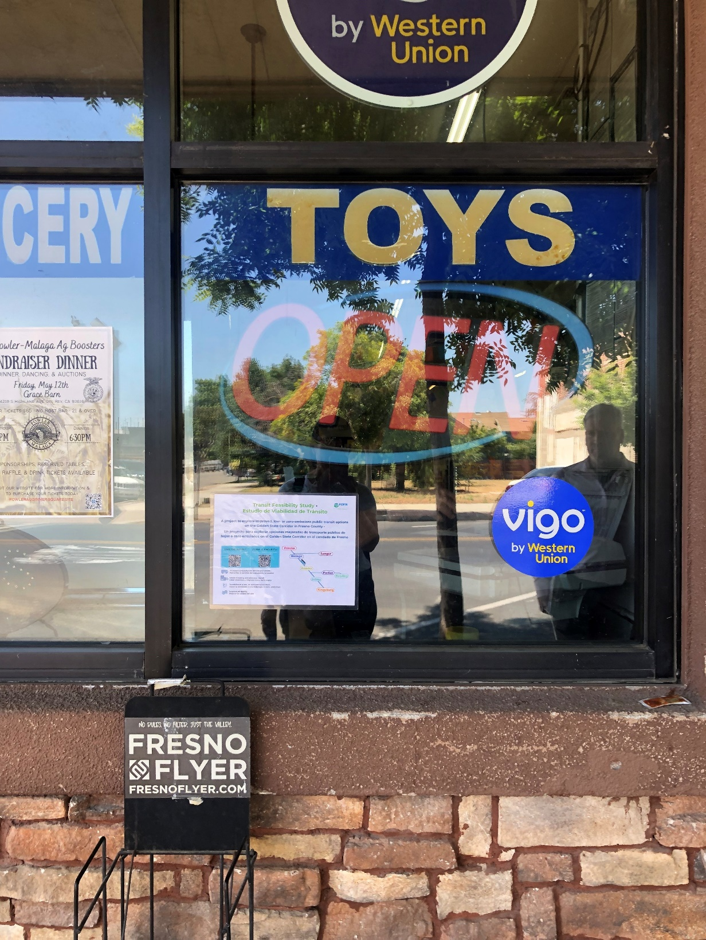
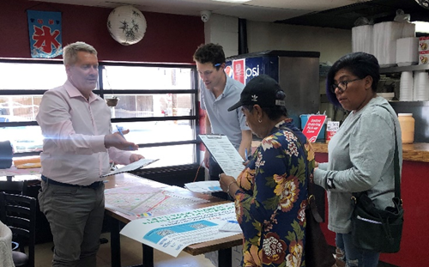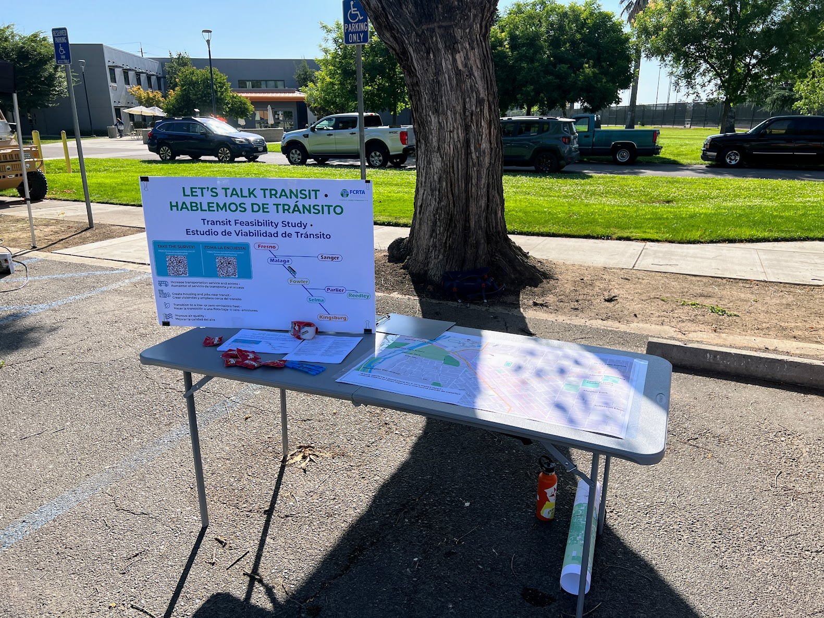

Microgrid and Resiliency Hub Feasibility Study--2024 Activities
The FCRTA Microgrid and Community Resiliency Hub Feasibility Study that began in 2023 and continued until it was completed in May of 2024. This study project engaged more than 300 community members. The goals of the outreach was to educate the community about FCRTA services and gather feedback on the future microgrid/resiliency hubs. Many meetings were held throughout Fresno County to gather community input into this study. All meeting materials were available in English and Spanish (website, survey, flyers, poster boards).

During 2023 the Microgrid and Resiliency Hub Feasibility Study began and was prepared by Walker Consultants. The writing of this study was greatly aided by substantial community feedback provided during community pop-up events that occurred in Reedley, Firebaugh, Parlier, Kerman, Huron, and Fowler on March 14-16, 2023, with more than 300 people attending in total. In addition to the 300 attendees of these meetings, FCRTA received 394 written survey responses regarding this study.

FCRTA continued the community meetings that began in 2023 into 2024 until the Microgrid and Resiliency Hub Feasibility Study was completed in May of 2024. In 2024 an advisory committee was formed to review the progress of the Microgrid and Resiliency Hub Feasibility Study and to review the final study document that was released in May of 2024. The final meetings of the advisory committee were held on February 27, 2024, and June 20, 2024.

Outreach materials for all popup meetings and advisory committee meetings were made in English and Spanish. Examples of an event flyer, meeting content, and a photo from a 2024 meeting are shown below.

2024 FCRTA On-Board Survey
FCRTA was part of a comprehensive transit on-board rider survey that was conducted in Fresno County in 2024 on behalf of the Fresno Council of Governments (FCOG) and all three of the region’s transit providers, including FCRTA. The survey provided a detailed overview of rider travel patterns and collected important information regarding transit customers, including (a) socio-demographics, (b) fare payment, (c) travel purpose, (d) means of access and egress to/from the system, (e) time of travel, and (f) ultimate origins and destinations.

The survey was conducted on-site by trained interviewers in March and April of 2024, primarily using tablet computers. The survey targeted 10% of average weekday boardings for FCRTA. Overall, 3,013 completed and statistically valid survey records were collected across all three service providers (Clovis Transit, FAX, and FCRTA), exceeding the targeted sample plan by 10%. For FCRTA specifically, 25 valid surveys were obtained, exceeding the sample target by 67%. The collected data for FCRTA were weighted and expanded based on counts by route only. After completing data processing and weighting, the total number of records closely approximated actual weekday ridership.

Arrangements were made for Spanish speaking riders or other non-Spanish speaking LEP riders to participate in this survey. For respondents who were unable to complete the interview during their transit trip, an option was provided to share their phone numbers or email addresses to receive an online version of the survey via text or email. For non-English speaking riders where the interviewer did not speak their language, the tablet provided instructions in the relevant language, prompting the rider to provide their name and phone number for further communication. Additionally, Spanish, Hindi, Russian, Karen, Hmong, Arabic, Vietnamese, Tagalog, and Chinese-language paper surveys was available for those who preferred to complete a self-administered version on the vehicle.

The survey contractor (ETC) provided an onsite project manager and a field supervisor to oversee the data collection process. A local staffing firm, ANIK, was contracted to supply staff for conducting the interviews. A total of 10 contracted staff members worked in two daily shifts, morning and afternoon, to ensure data was collected throughout all operating hours. All staff underwent comprehensive field training. The training covered the survey's purpose and objectives, use of the survey instruments, scripts for responding to passenger questions, proper use of data collection tools, public interaction guidelines, and safety protocols.

Survey staff training included the following details:
• How to intercept/interact with non-English speakers and LEP passengers.
• Cultural sensitivity
• Importance of understanding the intent of the questions.
• Instructions on conveying the purpose of the survey to passengers.
• Importance of data confidentiality and instruction on how to address passenger concerns.

The survey results were used to aid FCRTA in its planning of future transit services. A notable finding of the survey indicated that FCRTA transit users are highly dependent on transit for their trips, with 80% of FCRTA respondents identifying as non-choice riders (those without other transportation options). The survey also yielded useful information regarding the languages spoken by FCRTA riders and this information is discussed in the Four-Factor Analysis section of this document.

Fresno County Mobility Hubs Feasibility Study
FCOG utilized a FY 2023-24 Caltrans Sustainable Transportation Planning Grant for the Fresno County Mobility Hubs Feasibility Study and FCRTA was a project partner in this study. The aim of this study was to identify and prioritize potential site locations for mobility hubs near existing or planned transit, dependent on future funding. This study identified two prospective rural locations: Parlier and San Joaquin.
The study held three pop-up events for community outreach in FCRTA’s service area. This included the Kerman Harvest Festival on September 19, 2024, Kingsburg Crayfish Festival on September 21, 2024, and the Reedley Fiesta on October 11 and 12, 2024. During each pop-up event, the project team shared information on the project to gather community feedback and also had surveys in English and Spanish.

In July 2025, the project team hosted two community workshops. These workshops includes key stakeholders and were open to the public to gather input of the proposed locations of the mobility hubs and suggested amenities. There were display boards to illustrate the project and attendees were able to design their ideal mobility hub. The first rural workshop was on July 15, 2025, in Parlier and the second was in San Joaquin on July 16, 2025. Below and on the next page is the project flyer in English and Spanish and photos of the Parlier and San Joaquin events are on the following page.

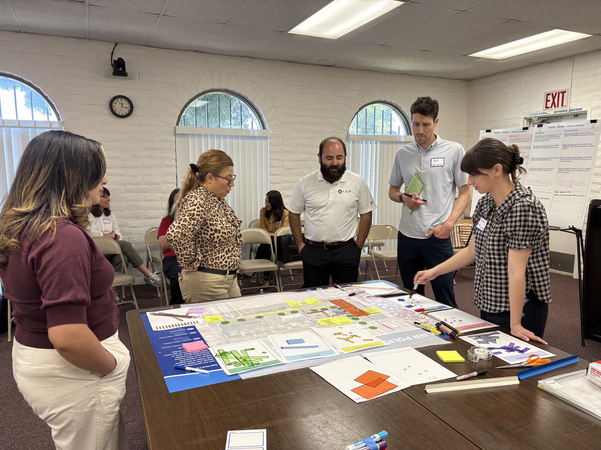
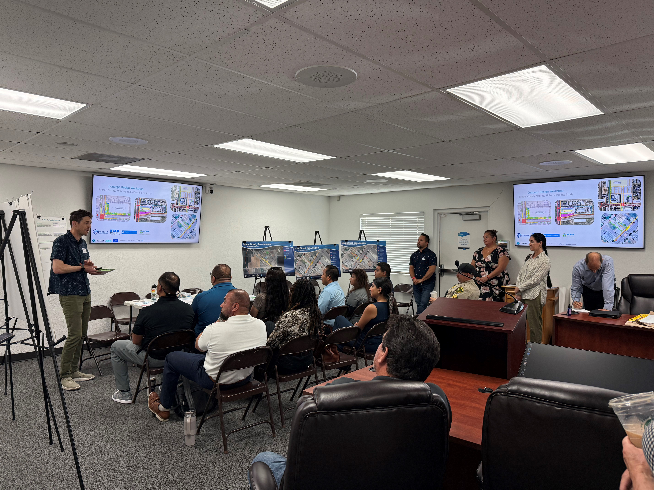

2025 Grand Opening FCRTA Maintenance & Operations Facility in Selma
As discussed in Attachment H, the FCRTA Equity Analysis For New Bus Maintenance
Facility, a new Maintenance & Operations Facility was constructed in Selma California for FCRTA following a lengthy community planning process that included the Equity Analysis that is in this document. Construction of this facility began in April of 2023 with a groundbreaking ceremony held on April 21, 2023.
FCRTA Maintenance Facility Groundbreaking Ceremony

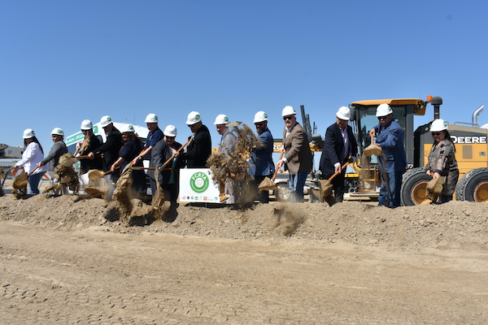

As construction of this facility progressed in 2024 and 2025, FCRTA conducted community outreach efforts and invited many community groups and local Selma residents and stakeholders to tour this facility while it was under construction.

From: Measure C Fresno County Social Media Content
“Take a look at a recent tour of the nearly completed Maintenance Facility in Selma! FCRTA was honored to host a tour for the middle school summer program, even in triple digit heat. These students are passionate about transportation and were in awe over the one-of-a-kind facility! We look forward to completing this project and seeing where careers in transportation lead the next generation.”

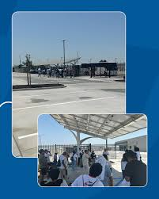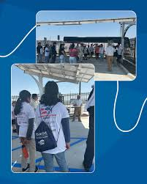
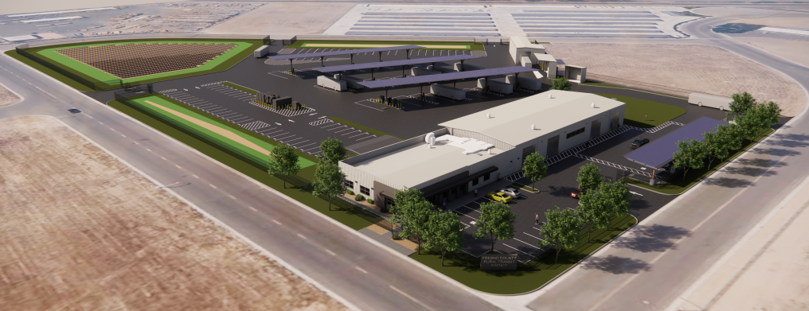

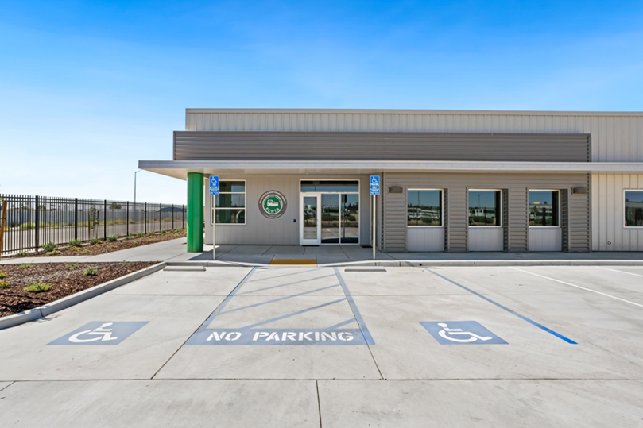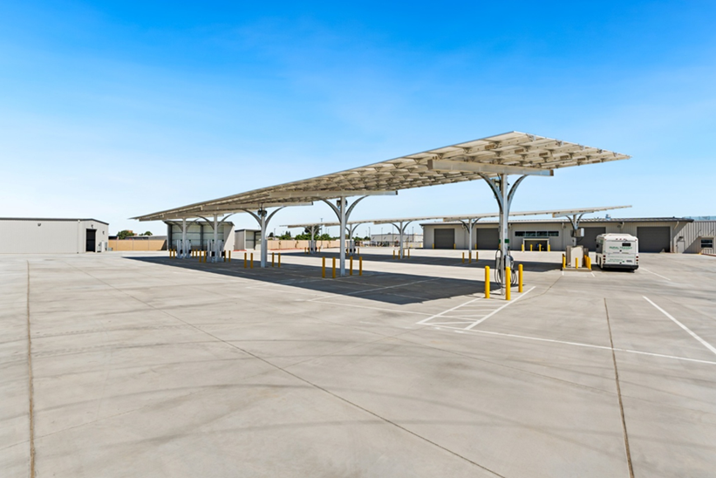

On August 22, 2025, the new Fresno County Maintenance & Operations Facility had its grand opening and Ribbon Cutting Ceremony. Many Selma residents, local and regional dignitaries, and members of the media attending this event that celebrated the opening of this very important transit facility that will support all FCRTA transit operations throughout Fresno County.

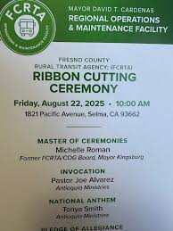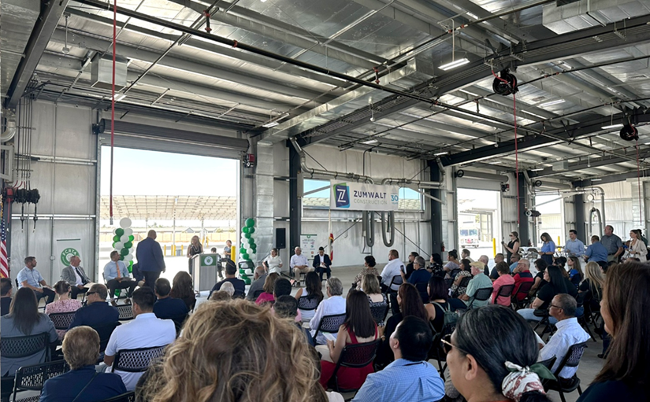

Both Assemblyman Dr. Joaquin Arambula and Congressman Jim Costa attended and spoke at the Ribbon Cutting Ceremony. A few comments from Dr. Joaquin Arambula, shown below, were part of a social media post from TETER Architects & Engineers, one of the firms that helped construct this facility.

From: TETER Architects & Engineers, Selma Social Media Content
Fresno County Rural Transit Agency is on a roll, with sustainability at the forefront!

FCRTA celebrated the grand opening of its new Regional Operations and Maintenance Facility, advancing clean and accessible transit for Fresno County’s rural communities.

This innovative facility supports a Zero Net Energy (ZNE) transit fleet, accommodating both natural gas and electric transit buses. It features on-site solar power and battery storage, water recycling, bio-swales, and drought-tolerant landscaping. A dedicated training area and administrative dispatch office are also included.

FCRTA prioritizes equitable access to transportation, serving the elderly, veterans, people with disabilities, and low-income or limited-English residents across the region.

“This facility is key to meeting the transit needs of our rural communities — especially seniors, veterans, people with disabilities, and others who have no way to get to doctors’ visits or make other appointments for vital services. At the same time, this facility decreases our dependence on fossil fuels by enabling the transition to electric buses. A great day for Fresno County and the region!” - Dr. Joaquin Arambula

Congressman Jim Costa made comments below regarding the new FCRTA facility.

From: Jim Costa Instagram Post, August 22, 2025
The opening of the FCRTA Regional Operations & Maintenance facility, dedicated to Mayor David T. Cardenas, shows what’s possible when all levels of government work together. This facility will support cleaner buses, lower costs, and improve our Valley’s air quality.
As a strong advocate for rebuilding the Valley’s infrastructure, I’m proud to see these investments being delivered for our community.

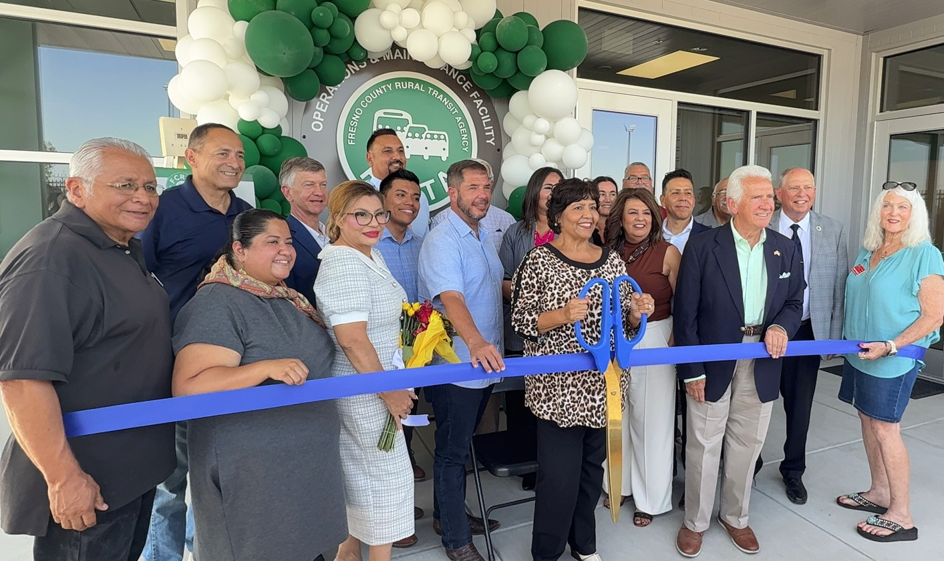

Annual Unmet Transit Needs Process
FCOG, as the regional transportation planning agency for Fresno County, is required under the California Transportation Development Act (TDA) to conduct an annual formal hearing process that solicits information about transit needs within Fresno County. Public participation is a key component of the TDA. Prior to making any allocation to member agencies (such as FCRTA) not directly related to public transportation services, specialized transportation services, or facilities provided for the exclusive use of pedestrians and bicycles, FCOG must annually identify the unmet transit needs of all residents in the County and those needs that are reasonable to meet. This process involves public outreach and a public hearing before the FCOG Board to solicit comments on unmet needs that might be reasonable to meet by establishing or expanding public transportation services, and the adoption by resolution of findings related to public comments. The FCRTA is responsible for implementing service changes to accommodate any unmet needs within its jurisdiction that are found to be “reasonable to meet”, prior to receiving TDA funding for that year.

For the Unmet Transit Needs meetings in 2026, public comments were invited through a wide array of mailing lists and agency contacts, by surface mail or email, and through testimony received in-person, by phone, or at the hearing. Bilingual posters and comment forms are posted at key stakeholder agencies and community organizations, as well as onboard all buses that operate within Fresno County. Surveys were done both in English and Spanish. The Spanish language version of the Unmet Transit Needs Survey is shown below. The hearing is conducted in both English and Spanish. FCRTA advertises the meeting on their website and onboard their buses. The Spanish language versions of the Unmet Needs meeting notice, comments request, and survey are shown following the online survey discussed below.

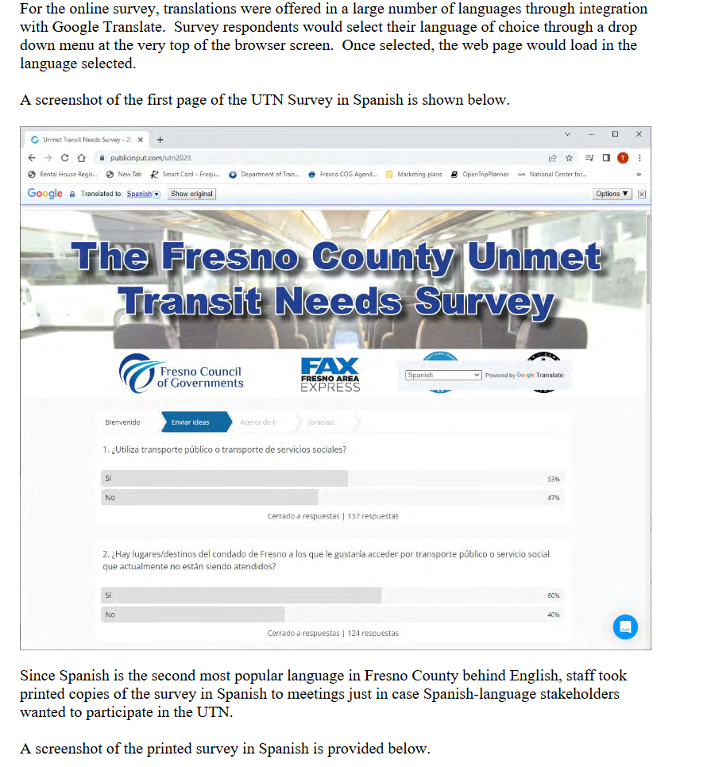
Encuesta: Necesidades de transporte público
insatisfechas 2026

¡Bienvenido!
La evaluación de Necesidades de Tránsito Insatisfechas (UTN) se realiza anualmente para identificar las necesidades de transporte insatisfechas que son razonablemente satisfechas y que aún no se están satisfaciendo a través de los servicios de transporte público existentes con fondos disponibles. La opinion y los comentarios del público son fundamentales en el proceso de la UTN. En colaboración con los proveedores de transporte locales, el COG de Fresno está recopilando comentarios del público sobre las Necesidades de Tránsito Insatisfechas del Condado de Fresno. Todos los comentarios deben presentarse antes del 3 de abril de 2026 a las 17:00 hy se consideran parte de la evaluación de la UTN de 2026.

1. ¿Utiliza actualmente el transporte público o transporte de servicio social?

Sí.
No, no lo hago.

2. ¿Cuál es el código postal de su casa?

3. ¿Hay lugares en el condado de Fresno a los que desea llegar utilizando el transporte público o los servicios sociales, pero no hay ningún servicio disponible?

Sí
No

4. ¿Qué son y dónde están los lugares?
_______________________________________________________________________________________________________________________________________________________________________________________________________________________________________

5. ¿Qué días necesitas servicio en los lugares que mencionaste?

Días laborables
fines de semana
Ambos

6. ¿A qué horarios necesita el servicio en las ubicaciones que indicó?
_______________________________________________________________________________________________________________________________________________________________________________________________________________________________________

7. ¿Qué autobús o sistema de transporte público opera en la zona donde se encuentra su ubicación sugerida? Seleccione todas las opciones que correspondan.

Fresno Area Express (FAX)
Handy Ride, el servicio de paratránsito de la ciudad de Fresno
Línea de escenario de Clovis
Clovis Round-Up, el servicio de paratránsito de la ciudad de Clovis
Agencia de Tránsito Rural del Condado de Fresno (FCRTA)
Un proveedor de agencia de servicios sociales

¿Tienes otras necesidades o sugerencias? Compártelas.
_______________________________________________________________________________________________________________________________________________________________________________________________________________________________________

Si desea que nos pongamos en contacto con usted, incluya su nombre y datos
de contacto a continuación. De lo contrario, haga clic en "Continuar".

Nombre de pila
_____________________________________________________________________________

Apellido
_____________________________________________________________________________

Correo electrónico
_____________________________________________________________________________

Teléfono
_____________________________________________________________________________

Gracias por tomarte el tiempo para
compartir tus ideas con nosotros.

Puede dejar un mensaje de voz para el personal con más comentarios sobre las necesidades de transporte insatisfechas. Llame al 855-925-2801, ingrese el código de proyecto 5248 cuando se le solicite y luego hable para dejar un mensaje de voz.

Si tiene alguna pregunta sobre el proceso y desea hablar directamente con representantes de la Agencia de tránsito, únase a nosotros en uno de los eventos virtuales plani􀀁cados que se enumeran en este enlace (https://publicinput.com/utn2026) o envíe un correo electrónico a Harold Sobrado a Harold.sobrado@fresno.gov (mailto:Harold.sobrado@fresno.gov) .

Nombre
_____________________________________________________________________________

Correo electrónico
_____________________________________________________________________________

DIRECCIÓN
_____________________________________________________________________________

COMPLAINTS/LAWSUITS AND APPEALS
How to File a Title VI Complaint with Fresno County Rural Transit Agency: Any person who believes that he/she, or as a member of any specific class of individuals, has been subjected to discrimination on the basis of race, color, national origin, age sex, sexual orientation, or gender identity with respect to Fresno County Rural Transit Agency programs, activities, services, or other transit related benefits, may file a written Complaint with Fresno County Rural Transit Agency. A Complaint may be filed by the individual or by a representative. A Complaint must be filed within one hundred and eighty (180) days after the date of the alleged discrimination, but complainants are encouraged to submit complaints as soon as possible. Fresno County Rural Transit Agency will continue to promptly investigate all Complaints filed under Title VI, pursuant to this Regulation.
Complaint must include the following information:
1. A Complaint must be in writing and signed and dated by the Complainant or his/her representative before any action can be taken.
2. A Complaint shall State, as fully as possible, the facts and circumstances surrounding the alleged discrimination, including the name and address of the complainant, the date, time and location of the incident. The Complaint shall include a description of the program, activity or service on which the alleged discrimination occurred.
A Complaint Form (Attachment B) can continue to be used to file a Title VI complaint with Fresno County Rural Transit Agency. A Complaint Form will continue to be made in an accessible format, upon request. A Complaint Form can be obtained at:
1. Fresno County Rural Transit Agency's website www.ruraltransit.org
2. By calling Fresno County Rural Transit Agency at (559) 233-6789 a complaint form can be mailed.
3. By picking up a complaint form at 2035 Tulare Street, Suite 201, Fresno, CA 93721
If the Complaint is received by anyone besides Fresno County Rural Transit Agency's General Manager, the individual in receipt of the Complaint shall forward it to the General Manager or his/her designee as soon as practicable but no later than two (2) business days of receipt. The General Manager shall immediately provide a copy of the Complaint to the Chair of the Board of Directors regarding the program, activity or service that is identified as being out of compliance.
Procedures for Investigating Complaints
The General Manager or his/her designee shall promptly investigate the alleged complaint and shall prepare a written response as soon as practicable, but no later than ten (10) business days of his/her receipt of the complaint. The General Manager or his/her designee may consult with appropriate staff in the preparation of his/her response to the complaint.

Efforts to Contact Complainant
The General Manager or his/her designee shall make efforts to speak (meeting or telephone conversation) with the complainant, at which time the complainant may give written or oral evidence supporting the allegation that his/her rights under Title VI have been violated. The General Manager or his/her designee shall review and consider the response prepared by the General Manager or his/her designee, all the information provided by the complainant, if any, and any other evidence available regarding the allegations of the complaint. The General Manager or his/her designee shall prepare a written report of his/her findings and if corrective action is required, a timetable for the completion of such action.
Completion of Investigation
As soon as it is practicable, but no later than twenty (20) business days following receipt of the initial complaint, the General Manager or his/her designee shall inform the complainant of his/her findings and any corrective action to be taken as a result of the complaint together with the timetable for completion of such action.
Appeal to Chairman of the Fresno County Rural Transit Agency’s Board of Directors
If the complainant is not satisfied with the findings and/or action of Fresno County Rural Transit Agency's General Manager or his/her designee, then the complainant may file his/her Complaint with the Chair of the Board of Directors or with the FTA's Office of Civil Rights.
Appeal Process
If the complainant chooses to file his/her Complaint with the Chair of the Board of Directors, then the complaint and any supporting documentation should be submitted within five (5) business days of his/her receipt of the results of the General Manager's investigation, with the Chair of the Board of Directors by providing it to General Manager at Fresno County Rural Transit Agency facility. Upon review of the file, the Chair of the Board of Directors shall notify the complainant of what actions, if any, will continue to be taken as a result of the review by the Chair within ten (10) business days of the Chair's notification that the complainant is not satisfied with the results of the General Manager's investigation. The decision of the Chair of Fresno County Rural Transit Agency Board of Directors shall be final.
Timeline Waiver
Any timeline set forth herein may be extended by the General Manager upon a showing of good cause.
How to File a Title VI Complaint with the FTA Office of Civil Rights
Any person who believes that he/she or as a member of any specific class of individuals, has been subjected to discrimination on the basis of race, color, national origin, age, sex, sexual orientation, or gender identity, with respect to Fresno County Rural Transit Agency's programs, activities, or services, or other transit related benefits, may file a written Complaint with FTA. A Complaint may be filed by the individual or by a representative. A Complaint must be filed within one hundred and eighty (180) days after the date of the alleged discrimination. FTA will continue to promptly investigate all Complaints filed under Title VI in accordance with the United States Department of Transportation (USDOT) regulations 49 CFR 21.11(b) and 21.11(c).
- A Complaint must include the following information: A Complaint must be in writing and signed and dated by the Complainant or his/her representative before any action can be taken. In cases where a Complainant is unable or incapable of providing a written Statement, but wishes FTA or DOT to investigate alleged discrimination, a verbal Complaint of discrimination may be made to the FTA Director, Office of Civil Rights. If necessary, the Civil Rights Official will continue to assist the person in converting the verbal Complaint into writing. All Complaints must, however, be signed by the Complainant or his/her representative.
FTA Civil Rights Office Address:
Federal Transit Administration Office of Civil Rights
Attention: Title VI Program Coordinator
East Building, 5th Floor – TCR
1200 New Jersey Avenue, S.E.
Washington, DC 20590
TTY: 1-800-877-8339
Voice: 1-866-377-8642
(E) www.FTA.ADAAssistance @dot.gov
2. A Complaint shall State, as fully as possible, the facts and circumstances surrounding the alleged discrimination, including the date, time and location of the incident. The Complaint shall include a description of the program, activity or service on which discrimination occurred.
Complaint Acceptance
Once a Complaint has been accepted, FTA will continue to notify Fresno County Rural Transit Agency that it has been subject to a Title VI Complaint and ask Fresno County Rural Transit Agency to respond in writing to the Complainant's allegations. Once the Complainant agrees to release the Complaint to Fresno County Rural Transit Agency, FTA will provide the Fresno County Rural Transit Agency with the Complaint. FTA may choose to close a Complaint if the Complainant does not agree to release the Complainant to the Fresno County Rural Transit Agency. FTA strives to complete a Title VI Complaint investigation within one hundred and eighty (180) days of the acceptance date of a Complaint.
Investigations
FTA will continue to make a prompt investigation whenever a compliance review, report, Complaint or any other information indicates a possible failure to comply with Title VI Regulations. FTA's investigation will continue to include a review of the pertinent practices and policies of Fresno County Rural Transit Agency, the circumstances under which the possible noncompliance occurred, and other factors relevant to a determination as to whether Fresno County Rural Transit Agency has failed to comply with Title VI regulations.
Following the investigation, FTA's Office of Civil Rights will continue to transmit to the Complainant and Fresno County Rural Transit Agency one of the following three (3) letters based on its finding:
1. Letter of Resolution: which explains the steps that Fresno County Rural Transit Agency has taken or promises to take to come into compliance with Title VI.
2. Letter of Finding (Compliance): which explains that Fresno County Rural Transit Agency is found to be in compliance with Title VI. This letter will continue to include an explanation of why Fresno County Rural Transit Agency was found to be in compliance, and provide notification of the Complainant's appeal rights.
3. Letter of Finding (Noncompliance): which explains that Fresno County Rural Transit Agency is found to be in noncompliance. This letter will continue to include each violation referenced, the applicable regulations, a brief description of proposed remedies, notice of the time limit on the conciliation process, the consequences for failure to achieve voluntary compliance, and an offer of assistance to Fresno County Rural Transit Agency in devising a remedial plan for compliance.
Appeals Process
The letters of finding and resolution will continue to offer the Complainant and Fresno County Rural Transit Agency the opportunity to provide additional information that would lead FTA to reconsider its conclusions. FTA requests that the parties in the Complaint provide this additional information within sixty (60) days of the date of the FTA letter of finding. PTA's Office of Civil Rights will continue to respond to an appeal either by issuing a revised letter of resolution or finding to the appealing party, or by informing the appealing party that the original letter of resolution or finding remains in force.
DEFICIENCIES WITH TITLE VI COMPLIANCE
Compliance Reviews will continue to be conducted periodically by FTA, as part of its ongoing responsibility pursuant to its authority under 49 CFR 21.11(a).
If FTA determines that Fresno County Rural Transit Agency is in noncompliance with Title VI, it will continue to transit a Letter of Finding that describes FTA's determination and requests that Fresno County Rural Transit Agency voluntarily take corrective action(s) which FTA deems necessary and appropriate.
Fresno County Rural Transit Agency will continue to submit a remedial action plan including a list of planned corrective actions and, if necessary, sufficient reasons and justification for FTA to reconsider any of its findings or recommendations within thirty (30) days of receipt of FTA's Letter of Finding.

ADMINISTRATION OF REGULATION
Fresno County Rural Transit Agency will continue to integrate the provisions within its Title VI Program into all programs, activities, and services provided by Fresno County Rural Transit Agency.
Fresno County Rural Transit Agency will continue to integrate the Title VI Program into its policies and procedures.

SECTION 2:
LIMITED ENGLISH PROFICIENCY (LEP) PLAN
INTRODUCTION
This Limited English Proficiency (LEP) Plan has been prepared to address the Fresno County Rural Transit Agency responsibilities as a recipient of federal financial assistance as they relate to the needs of individuals with limited English language skills. The plan has been prepared in accordance with Title VI of the Civil Rights Act of 1964, Federal Transit Administration Circular 4702.1A dated May 13, 2007, which States that no person shall be subjected to discrimination on the basis of race, color or national origin.
Executive Order 13166, titled Improving Access to Services for Persons with Limited English Proficiency, indicates that differing treatment based upon a person's inability to speak, read, write or understand English is a type of national origin discrimination. It directs each federal agency to publish guidance for its respective recipients clarifying their obligation to ensure that such discrimination does not take place. This order applies to all State and local agencies which receive federal funds.
PLAN SUMMARY
Fresno County Rural Transit Agency is the public transit operator for the Fresno County and has developed this LEP Plan to help identify reasonable steps for providing language assistance to persons with limited English proficiency who wish to access services provided by Fresno County Rural Transit Agency. As defined in Executive Order 13166, LEP persons are those who do not speak English as their primary language and have limited ability to read, speak, write or understand English.
This plan outlines how to identify a person who may need language assistance, the ways in which assistance may be provided, staff training that may be required, and how to notify LEP persons that assistance is available.
In order to prepare this plan, Fresno County Rural Transit Agency undertook the U.S. Department of Transportation (U.S. DOT) four (4) factor LEP analysis which considers the following factors:
1. The number or proportion of LEP persons in the service area who may be served or are likely to encounter a Fresno County Rural Transit Agency program, activity or service.
2. The frequency with which LEP persons come in contact with Fresno County Rural Transit Agency programs, activities or services.
3. The nature and importance of programs, activities or services provided by Fresno County Rural Transit Agency to the LEP population.
4. The resources available to Fresno County Rural Transit Agency and overall costs to provide LEP assistance.
A summary of the results of the Fresno County Rural Transit Agency four-factor analysis is in the following section.
Four-Factor Analysis
1. The number or proportion of LEP persons in the service area who may be served or are likely to encounter a Fresno County Rural Transit Agency program, activity or service.
Fresno County Rural Transit Agency staff reviewed the 2020 U.S. Census (2024 Update) and determined that 429,177 persons in Fresno County [44.9 % of the population] speak a language other than English. In Fresno County, 174,346 persons [18.3%] indicate having limited English proficiency; that is, they speak English "not very well".
In Fresno County, of those persons with limited English proficiency, 326,262 (34.2% of the total population) speak Spanish; the remaining respondents speak approximately 66 different languages, accounting for less than 10% of the population.
In addition to Spanish, LEP persons exceed 1,000 speakers in Fresno County in the languages of Arabic, Tagalog, Russian, and Chinese. While the total number of LEP persons in Fresno County for each language of Arabic, Tagalog, Russian, and Chinese exceed 1,000 LEP speakers per language, the amount of LEP persons, per language, likely to be encountered by FCRTA is extremely low, probably as low as 10 to 25 per year. It is even possible, due to the nature of FCRTA’s service, that there could be zero people from one of these LEP groups encountered during a given year. This is because historically, very few of these LEP speakers in all of these languages are typically encountered by FCRTA.
Since the last update of FCRTA’s Title VI Program in 2023, an On-Board Rider Survey was conducted that ended in April of 2024. This statistically valid survey of 25 surveys provided useful information to FCRTA regarding different languages spoken by FCRTA riders. This survey asked riders how well they spoke English, if they spoke in a language other than English, and if so, which languages other than English that they spoke. Riders were offered this survey in English, Spanish, Hindi, Russian, Karen, Hmong, Arabic, Vietnamese, Tagalog, and Chinese.
Of the 25 riders surveyed, 13 or 52% responded that they spoke a language other than English. Of these 13 respondents, 12 or 92.3% spoke Spanish and 1 or 7.7% spoke Arabic. Of these 13 respondents that spoke a language other than English, only 1 or 7.7% said that they did speak English well at all. 12 of these respondents said they spoke English very well.
This survey data has served to reinforce FCRTA’s perception that the number of LEP persons using FCRTA service that are non-Spanish speakers, is very low.
It is important to stress that FCRTA does not typically serve or encounter many LEP persons that speak languages other than Spanish. One reason for the lack of encounters is that many of these LEP speakers do not reside in the primary service areas of FCRTA bus service. Most of FCRTA bus service serves small, rural farming towns outside of Fresno that are made up of mostly Hispanic people that speak either English or Spanish or both languages. FCRTA historically has encountered very few, if any, LEP speakers of other languages besides Spanish. FCRTA’s believes that the vast majority of the LEP populations of languages other than Spanish, live in the Fresno and Clovis metropolitan area with only very small numbers living in the very small towns of rural Fresno County. It is important to note that FCRTA does not provide a significant amount of transit service in the Fresno and Clovis metropolitan areas thus explaining how it encounters few LEP persons that speak languages other than Spanish.
Another reason for the lack of encounters is that many of these non-Spanish LEP speakers in rural areas are not low income, or users of the rural oriented bus service that FCRTA provides. Typically, these other LEP populations have higher incomes and own a vehicle and do not have the need for use of FCRTA’s bus service. Most FCRTA riders are low-income farm workers or unemployed people.
(a) How LEP persons interact with the recipient’s agency;
The most frequent contact between LEP persons is with bus drivers and dispatchers. Because the number of non-Spanish speaking LEP persons is very low in Fresno County, and these LEP populations are very unlikely to use FCRTA bus service, it is presumed that very few non-Spanish speaking LEP persons ride the bus and encounter the bus driver or call FCRTA and speak to a call taker or dispatcher. While FCRTA does have the ability to contact speakers of the appropriate language and do language translations, FCRTA has very rarely ever had to do this in the past. Also, the vast majority of FCRTA outreach activities take place in small rural communities where very few, if any, LEP persons of the non-Spanish languages live. Furthermore, historically LEP persons of non-Spanish languages typically do not attend FCRTA outreach events or activities. Had they, FCRTA would have arranged for interpreting services of the appropriate language.
(b) Identification of LEP communities, and assessing the number or proportion of LEP persons from each language group to determine the appropriate language services for each language group;
The number of LEP persons, exceeding 1,000, from each non-Spanish language group in Fresno County (approximately) are as follows: Chinese-2,374 speakers. Tagalog-7,081 speakers. Russian-1,203 speakers. Arabic-4,534 speakers. As discussed earlier, FCRTA encounters only a tiny fraction of these speakers when providing its transit services. Because only a very small number of these speakers are very rarely encountered by FCRTA staff, it is not an efficient practice to have speakers in these languages on staff, and it is only coincidental if FCRTA does have speakers of these languages on its staff. The most appropriate language service for each of these language groups is for FCRTA to secure the services of interpreting services when the need arises, which would be on very rare occasions. In addition to Spanish and English, FCRTA now has its Title VI Public Notice, Complaints Procedure and Complaint Form available in four LEP languages: Tagalog, Vietnamese, Arabic, Chinese.
(c) The literacy skills of LEP populations in their native languages, in order to determine whether translation of documents will be an effective practice; and
FCRTA does not believe that the translation of documents into the other non-Spanish languages would be an effective practice. This is because of two reasons. First, because there are so few very LEP speakers of languages other than Spanish using the FCRTA transit service and second, because with a few notable exceptions, FCRTA does not typically translate its agency documents into Spanish because this has not proven to be an effective practice due to the relatively low literacy skill of the Spanish LEP population in Fresno County.
(d) Whether LEP persons are underserved by the recipient due to language barriers.
FCRTA does not believe that LEP persons of languages other than Spanish is likely being underserved by FCRTA due to language barriers. Typically, if any LEP person of a language other than Spanish wishes to board an FCRTA bus, they are still able to do so. FCRTA has found that all LEP persons of any language, typically bring an English speaker with them if they need assistance while riding the bus so they can pay the fare or do anything else necessary for the bus trip. Also, all LEP persons of any language, typically have an English speaker make the phone call for them when they are contacting FCRTA call takers. FCRTA does not know of any past circumstances when a LEP speaker, of any language, was unable to contact FCRTA or not use an FCRTA bus when they wished to do so.
2. The frequency with which LEP persons come in contact with Fresno County Rural Transit Agency programs, activities or services.
Fresno County Rural Transit Agency assessed the frequency with which staff and drivers have, or could have, contact with LEP persons. This includes documenting phone inquiries and surveying vehicle operators for requests for interpreters and translated documents. To date, the most frequent contact between LEP persons is with bus drivers and dispatchers. Dispatchers take approximately 400 calls per day, with typical calls being;
- Requests for service to local community lunch providers
- Deviated service stop requests
- General services calls
- Questions about the FCRTA transit system
Based on this information, Fresno County Rural Transit requires the hiring of bilingual staff and works with local community service agencies identified as having high LEP person traffic and will ensure that language assistance information is posted in high volume areas, such as; buses, website and dispatch centers. In 2026, FCRTA has now added a Translation App to it website. This Translation App offers translations into 100 different languages enabling the LEP population to be able to access and understand the FCRTA website (ruralransit.org) and the services offered by FCRTA.
3. The nature and importance of programs, activities or services provided by Fresno County Rural Transit Agency to the LEP population.
The largest geographic concentration of LEP individuals in the Fresno County Rural Transit Agency service area is Spanish. 13 Concentrated areas have been identified as having very significant percentages of the population identified as Hispanic, they are; Coalinga (63.9%), Firebaugh (92.5%), Fowler (66.4%), Huron (95.7%), Kerman (78.2%), Kingsburg (48.3%), Mendota (96.6%), Orange Cove (94.9%), Parlier (97.6%), Reedley (79.1%), Sanger (82.6%), San Joaquin (95.6%), Selma (81.2%). Services provided by Fresno County Rural Transit Agency that are most likely to encounter LEP individuals are the fixed route system which serves the general public and the demand-response (Dial-A-Ride) system which serves primarily senior and disabled persons.
It is also likely that Fresno County Rural Transit Agency will continue to encounter LEP individuals at the Fresno County Rural Transit Agency offices where passes and taxi script are sold, community outreach events and posters are displayed relating to transit events.
4. The resources available to Fresno County Rural Transit Agency and overall costs to provide LEP assistance.
Fresno County Rural Transit Agency assessed its available resources that could be used for providing LEP assistance, including determining the cost of a professional interpreter and translation service on an as-needed basis, which of its documents would be the most valuable to be translated if the need should arise, and taking an inventory of available organizations that Fresno County Rural Transit Agency could partner with for outreach and translation efforts. The amount of staff and vehicle operating training that might be needed was also considered. Based on the four-factor analysis, Fresno County Rural Transit Agency developed its LEP Plan as outlined in the following section.

SAFE HARBOR

SAFE HARBOR PROVISION
The Federal Transit Authority Circular 4702.1B states:

DOT has adopted DOJ’s Safe Harbor Provision, which outlines circumstances that can provide a “safe harbor” for recipients regarding translation of written materials for LEP populations. The Safe Harbor
Provision stipulates that, if a recipient provides written translation of vital documents for each eligible LEP language group that constitutes five percent (5%) or 1,000 persons, whichever is less, of the total
population of persons eligible to be served or likely to be affected or encountered, then such action will be considered strong evidence of compliance with the recipient’s written translation obligation. Translation of non-vital documents, if needed, can be provided orally. If there are fewer than 50 persons in a language group that reaches the five percent (5%) trigger, the recipient is not required to translate vital
written materials but should provide written notice in the primary language of the LEP language group of the right to receive competent oral interpretation of those written materials, free of cost.

These safe harbor provisions apply to the translation of written documents only. They do not affect the requirement to provide meaningful access to LEP individuals through competent oral interpreters where oral language services are needed and are reasonable. A recipient may determine, based on the Four Factor Analysis, that even though a language group meets the threshold specified by the Safe Harbor Provision, written translation may not be an effective means to provide language assistance measures. For example, a recipient may determine that a large number of persons in that language group have low literacy skills in their native language and therefore require oral interpretation. In such cases, background documentation regarding the determination shall be provided to FTA in the Title VI Program.

The Spanish language is the only language spoken in rural Fresno County (FCRTA’s service area) that meets the 5% or 1,000 people criteria. FCRTA will continue to translate and distribute written vital documents in Spanish in order to satisfy the Safe Harbor provision and ensure FCRTA’s services are accessible. Additionally, four other languages now meet the 1,000 people criteria, Arabic, Tagalog, Russian, and Chinese in Fresno County. But these four languages are mainly concentrated in the urban areas of Fresno County. These four languages are discussed in the Four-Factor Analysis.

Below is a list of vital written documents that are in translated into Spanish:
- Bus Schedules
- Title VI Notice
- Title VI Complaint Instructions & Form
- Interior bus signs and/or flyers regarding transit fares and passenger rules
- FCRTA website (ruraltransit.org) Translation App that allows translations into 100 different languages.

As per Caltrans instruction, FCRTA now translates Title VI Public Notice, Complaints Procedure and Complaint Form into Tagalog, Vietnamese, Arabic, Chinese. These new translations are found following the English and Spanish versions of the Title VI Public Notice, Complaints Procedure and Complaint Form.

LIMITED ENGLISH PROFICIENCY (LEP) PLAN OUTLINE
How Fresno County Rural Transit Agency and staff may identify a LEP person who needs language assistance:
1. Examine records to see if requests for language assistance have been received in the past, either at meetings or over the phone, to determine whether language assistance might be needed at future events or meetings.
2. Have a bilingual staff person greet participants as they arrive to Fresno County Rural Transit Agency sponsored events. By informally engaging participants in conversation it is possible to gauge each attendee's ability to speak and understand English.
3. Have Census Bureau Language Identification Flashcards available at Fresno County Rural Transit Agency meetings. This will continue to assist Fresno County Rural Transit Agency in identifying language assistance needs for future events and meetings.
4. Fresno County Rural Transit Agency I Title VI Program Section 2: Limited English 4. Have Census Bureau Language Identification Flashcards on all transit vehicles to assist vehicle operators in identifying specific language assistance needs of passengers. If such individuals are encountered, vehicle operators will continue to be instructed to try to obtain contact information to give to Fresno County Rural Transit Agency staff and management for follow-up.
5. Vehicle operators and other front-line staff, like dispatchers, dial-a-ride schedulers, and service development planners, will continue to be surveyed on their experience concerning any contacts with LEP persons during the previous year.
LANGUAGE ASSISTANCE MEASURES
There are numerous language assistance measures available to LEP persons, including both oral and written language services. There are also various ways in which Fresno County Rural Transit Agency staff responds to LEP persons, whether in person, by telephone or in writing.
- Provide bilingual staffing to provide Spanish-speaking interpretation at its Administrative offices and within its Customer Service transit questions and trip planning.

- Network with local human service organizations that provide services to LEP individuals and seek opportunities to provide information on Fresno County Rural Transit Agency programs and services.
- Placement of Statements in notices and publications that interpreter services are available for these meetings, with seven (7) day advance notice.

- Survey bus drivers and other front-line staff, like dispatchers, dial-a-ride schedulers, and service development planners, annually on their experience concerning any contacts with LEP persons during the previous year.

- Provide Language Identification Flashcards at the Transit Center, onboard the Fresno Transit fleet, in Road Supervisor vehicles and at transit systems administrative offices.

- Post the Fresno County Rural Transit Agency Title VI Program and LEP Plan on the agency website, www.ruraltransit.org and at the administrative offices.

- Provide travel training to LEP persons with the assistance of bilingual staff.

- Include language "Spanish a plus" on bus driver recruitment flyers and onboard recruitment posters.

- When an interpreter is needed, for a language other than Spanish, in person or on the telephone, staff will continue to utilize a professional interpreter services.

In addition to the above measures, the FCRTA website (ruraltransit.org) homepage has a Translation App on it enabling LEP persons to be able to read the website in 100 different languages.
STAFF TRAINING
The following training will continue to be provided to Fresno County Rural Transit Agency staff:
1. Information on the Fresno County Rural Transit Agency Title VI Procedures and LEP responsibilities.
2. Description of language assistance services offered to the public.
3. Use of Language Identification Flashcards (used to identify language preference).
4. Documentation of language assistance requests.
5. Use of professional interpreter services (over the phone interpretation provider).
6. How to handle a potential Title VI / LEP complaint.
OUTREACH TECHNIQUES
In order to ensure that LEP individuals are aware of Fresno County Rural Transit Agency's language assistance measures, Fresno County Rural Transit Agency provides the following:
- Local schedules include Spanish translation
- Spanish language contact information, phone and email, is posted on the Fresno Transit website home page.
- Bilingual staff present most service hours for in-person or phone customer service at the administrative offices
- Most bus drivers are bilingual and assist LEP passengers if needed when driving
- All dispatchers are bilingual
- Fresno County Rural Transit Agency website Translation App

Additionally, when staff prepares a document or schedules a meeting, for which the target audience is expected to include LEP individuals, then documents, meeting notices, flyers, and agendas will continue to be printed and posted in an alternative language based on the known LEP population. These notices will continue to be posted in the following locations:

- Fresno County Rural Transit Agency Administrative offices.
- Fresno County Rural Transit Agency buses.
- Fresno County Rural Transit Agency website.
Such notices may also be posted or announced with local stakeholders, community centers and affected route major transfer points. Interpreters will continue to be available as needed.
MONITORING AND UPDATING THE LEP PLAN
Fresno County Rural Transit Agency will continue to update the LEP plan as required by U.S. DOT. At a minimum, the plan will continue to be reviewed and updated every three (3) years in conjunction with the Title VI submission, or when data from the U.S. Census is available, or when it is clear that higher concentrations of LEP individuals are present in the Fresno County Rural Transit Agency service area. Updates will continue to include the following:
- The number of documented LEP person contacts encountered annually.

- How the needs of LEP persons have been addressed.

- Determination of the current LEP population in the service area.

- Determination as to whether the need for translation services has changed.

- Determine whether local language assistance programs have been effective and sufficient to meet the need.

- Determine whether Fresno County Rural Transit Agency's financial resources are sufficient to fund language assistance resources needed.

- Determine whether Fresno County Rural Transit Agency has fully complied with the goals of this LEP Plan.

- Determine whether complaints have been received concerning Fresno County Rural Transit Agency's failure to meet the needs of LEP individuals.
DISSEMINATION OF THE FRESNO COUNTY RURAL TRANSIT AGENCY LEP PLAN
A link to the Fresno County Rural Transit Agency LEP Plan and the Title VI Program is included on the Fresno County Rural Transit Agency website at: www.ruraltransit.org.
Any person or agency with internet access will continue to be able to access and download the plan from the Fresno County Rural Transit Agency website. Alternatively, any person or agency may request a copy of the plan via telephone, mail, or in person and shall be provided a copy of the plan at no cost. LEP individuals may request copies of the plan in translation which Fresno County Rural Transit Agency will continue to provide, if feasible.
Questions or comments regarding the LEP Plan may be submitted to the Fresno County Rural Transit Agency, General Manager:
Janelle Del Campo
General Manager
Fresno County Rural Transit Agency
2035 Tulare Street, Suite 201
Fresno, CA 93721
(O) 559-233-6789
(F) 599-233-9645
(E) delcampo@fresnocog.org
(W) www.ruraltransit.org

NOTICE
Notifying the Public of Rights Under Title VI
Fresno County Rural Transit Agency operates its public transit assistance programs and services in the rural areas of Fresno County, without regard to race, color or national origin in accordance with Title VI of the Civil Rights Act of 1964. Any person who believes they has been aggrieved by any unlawful discriminatory practice under Title VI may file a complaint with Fresno County Rural Transit Agency.
For more information about the Fresno County Rural Transit Agency's Title IV Program and procedures to file a complaint, may contact the Agency’s Administrative Offices at 2035 Tulare Street, Suite 201; Fresno, CA 93721; or by phone at (559) 233-6789; or by Fax at 559-233-9645; or by website at www.ruraltransit.org.
A complainant or their designated representative may file a complaint directly with the Federal Transit Administration; Office of Civil Rights; Attention: Title VI Program Coordinator, East Building, 5th Floor-TCR, 1200 New Jersey Ave., SE, Washington DC 20590. If information is needed in another language, contact (559) 233-6789 for assistance. Si requiere información en otro idioma, llame al (559) 233-6789.
FACILITIES NOTICE
FCRTA has not recently constructed any facilities nor is it currently constructing any facility. If a facility has been constructed, a Title VI equity analysis must have been conducted during the planning stage regarding the location. A copy of the analysis must be provided. (Chapter III-11)
FCRTA recently did conduct an equity analysis for the construction of a new Maintenance facility in Selma.

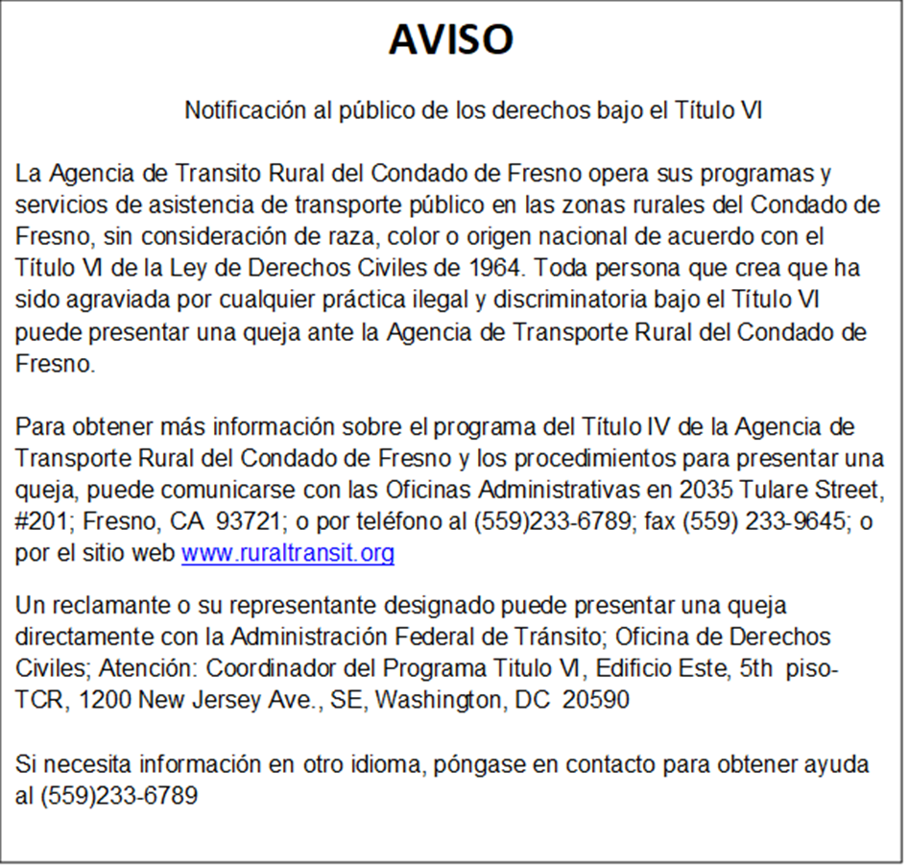

إخطار

إخطار الجمهور بالحقوق بموجب الباب السادس
تقوم وكالة النقل الريفي في مقاطعة فريسنو بتشغيل برامج وخدمات المساعدة في النقل العام في المناطق الريفية في مقاطعة فريسنو، بغض النظر عن العرق أو اللون أو الأصل القومي وفقًا للباب السادس من قانون الحقوق المدنية لعام 1964. يحق لأي شخص يعتقد أنه قد تعرض للظلم بسبب أي ممارسة تمييزية غير قانونية بموجب الباب السادس تقديم شكوى إلى وكالة النقل الريفي في مقاطعة فريسنو.
للحصول على مزيد من المعلومات حول برنامج الباب الرابع التابع لوكالة النقل الريفي في مقاطعة فريسنو وإجراءات تقديم الشكاوى، يمكن التواصل مع المكاتب الإدارية للوكالة على العنوان التالي: 2035 Tulare Street, Suite 201; Fresno, CA 93721؛ أو عبر الهاتف على الرقم 6789-233 (559)؛ أو عن طريق الفاكس على الرقم 9645-233-559؛ أو عبر الموقع الإلكتروني على www.ruraltransit.org.
يمكن لمقدم الشكوى أو ممثله المعين تقديم الشكوى مباشرةً إلى إدارة النقل الفيدرالية. منسق برنامج الباب السادس، East Building, 5th Floor-TCR, 1200 New Jersey Ave., SE, Washington DC 20590.
إذا كنت بحاجة للحصول على المعلومات بلغة أخرى، فاتصل بالرقم 6789-233 (559) للحصول على المساعدة. Si requiere información en otro idioma, llame al (559) 233-6789.

公告

公众依据《民权法案第六章》享有的权利
弗雷斯诺县农村交通局在弗雷斯诺县农村地区运营公共交通辅助项目与服务时，依据《1964 年民权法案第六章》，不因种族、肤色或国籍而歧视任何人。任何人如认为自身遭受《民权法案第六章》禁止的非法歧视行为，均可向弗雷斯诺县农村交通局提出投诉。
欲了解更多关于弗雷斯诺县农村交通局《民权法案第六章》项目及投诉程序的信息，可联系该局的行政办公室，地址：2035 Tulare Street, Suite 201; Fresno, CA 93721;或致电 (559) 233-6789；或传真至 559-233-9645；或访问网站www.ruraltransit.org.
投诉人或其指定代表可直接向联邦交通管理局提交投诉； 民权办公室； 收件人：《民权法案第六章》项目协调员，地址：East Building, 5th Floor-TCR, 1200 New Jersey Ave., SE, Washington DC 20590.
如需其他语言版本信息，请致电 (559) 233-6789 寻求协助。 Si requiere información en otro idioma, llame al (559) 233-6789.

PAUNAWA

Pagbibigay-alam sa Publiko tungkol sa mga Karapatan sa ilalim ng Titulo VI
Pinapatakbo ng Fresno County Rural Transit Agency ang mga programa at serbisyo nito sa pampublikong transportasyon sa mga rural na lugar ng Fresno County, nang walang pagsasaalang-alang sa lahi, kulay o bansang pinagmulan alinsunod sa Titulo VI ng Batas sa mga Karapatang Sibil ng 1964. Sinumang taong naniniwalang sila ay naapektuhan ng anumang ilegal na diskriminasyon sa ilalim ng Titulo VI ay maaaring maghain ng reklamo sa Fresno County Rural Transit Agency.
Para sa karagdagang impormasyon tungkol sa Programa sa Titulo IV ng Fresno County Rural Transit Agency at mga pamamaraan sa paghahain ng reklamo, maaaring makipag-ugnayan sa mga Administratibong Tanggapan ng Ahensya sa 2035 Tulare Street, Suite 201; Fresno, CA 93721; o sa pamamagitan ng telepono sa (559) 233-6789; o sa pamamagitan ng Fax sa 559-233-9645; o sa pamamagitan ng website sa www.ruraltransit.org.
Ang isang nagrereklamo o ang kanilang itinalagang kinatawan ay maaaring direktang maghain ng reklamo sa Federal Transit Administration; Office of Civil Rights; Para sa: Title VI Program Coordinator, East Building, 5th Floor-TCR, 1200 New Jersey Ave., SE, Washington DC 20590.
Kung kailangan ng impormasyon sa ibang wika, makipag-ugnayan sa (559) 233-6789 para sa tulong. Si requiere información en otro idioma, llame al (559) 233-6789.

THÔNG BÁO

Thông báo về Luật bảo vệ quyền lợi của công chúng theo Tiêu đề VI
Cơ quan Vận tải Nông thôn Quận Fresno điều hành các chương trình và dịch vụ hỗ trợ vận tải công cộng tại các khu vực nông thôn của Quận Fresno, không phân biệt chủng tộc, màu da hoặc nguồn gốc quốc gia theo Tiêu đề VI của Đạo luật Dân quyền năm 1964. Bất kỳ ai tin rằng mình đã bị xúc phạm do bất kỳ hành vi phân biệt đối xử bất hợp pháp nào theo Tiêu đề VI đều có thể nộp đơn khiếu nại đến Cơ quan Vận tải Nông thôn Quận Fresno.
Để biết thêm thông tin về Chương trình Tiêu đề IV của Cơ quan Vận tải Nông thôn Quận Fresno và các thủ tục nộp đơn khiếu nại, quý vị có thể liên hệ với Văn phòng Hành chính của Cơ quan tại địa chỉ 2035 Tulare Street, Suite 201; Fresno, CA 93721; hoặc qua điện thoại số (559) 233-6789; hoặc qua Fax số 559-233-9645; hoặc qua trang web tại www.ruraltransit.org.
Người khiếu nại hoặc người đại diện được chỉ định của họ có thể nộp đơn khiếu nại trực tiếp cho Federal Transit Administration; Office of Civil Rights; Attention: Title VI Program Coordinator, East Building, 5th Floor-TCR, 1200 New Jersey Ave., SE, Washington DC 20590.
Nếu cần thông tin bằng ngôn ngữ khác, vui lòng liên hệ (559) 233-6789 để được hỗ trợ. Si requiere información en otro idioma, llame al (559) 233-6789.

SECTION 3:
EQUITY ANALYSIS

SUMMARY

As required by Title VI of Civil Rights Act of 1964, Fresno County Rural Transit Agency (FCRTA) has conducted an Equity Analysis intended to ensure that the location of the planned new Bus Maintenance Facility was selected without regard to race, color, or national origin. In addition, as required under Executive Order 12898 Federal Actions to Address Environmental Justice in Minority Populations and Low-Income Populations, staff has completed a parallel review to ensure minority and low-income populations are not disproportionately affected by the selection of the preferred site.
Along with data and studies undertaken as part of the environmental review process, FCRTA has determined that the selection of the proposed Bus Maintenance Facility site at 1821 Pacific Avenue in Selma would not result in a disparate impact to minority or low-income populations.
The Equity Analysis document is included in Attachment H.

Attachment A
POLICY STATEMENT
The Fresno County Rural Transit Agency is committed to providing public transportation in an environment that is free from discrimination on the basis of race, color or national origin. Fresno County Rural Transit Agency operates its programs, activities and services without regard to race, color or national origin.
As a Federal Transit Administration (FTA) fund recipient, Fresno County Rural Transit Agency will continue to ensure that its programs, policies and activities comply with Title VI of the Civil Rights Act of 1964, as amended, and United States Department of Transportation regulations.
The Fresno County Rural Transit Agency has prepared and adopted a comprehensive Title VI Program, in compliance with Federal regulations. It is available for public awareness.
Any person, who believes that they, has been subjected to discrimination on the basis of race, color or national origin, with respect to Fresno County Rural Transit Agency's programs, activities, services, or other transit related benefits, may file a Title VI complaint, utilizing an available Form. Complaints must be filed in writing and signed by the complainant, or their designated representative, and should include the complainants name, address, and telephone number or other means by which the complainant can be contacted. Complaints should be filed as soon as possible to address and investigate and resolve the alleged Complaint in a timely manner. Otherwise, a Complaints must be filed within one hundred and eighty 180 days of the date of the alleged discriminatory act.
To request additional information on Fresno County Rural Transit Agency's non-discrimination obligations or to file a Title VI Complaint Form, please submit your request or complaint in writing to:
Fresno County Rural Transit Agency
Janelle Del Campo
General Manager
2035 Tulare Street, Suite 201
Fresno, CA 93721
(O) 559-233-6789
(F) 559-233-9645
(E) delcampo@fresnocog.org
(W) www.ruraltransit.org

Complaint Forms can also be obtained at: www.ruraltransit.org

Federal Transit Administration (FTA) Title VI Complaints may be filed directly to:
Federal Transit Administration Office of Civil Rights
Title VI Program Coordinator
East Building, 5th Floor – TCR
1200 New Jersey Avenue, SE
Washington, DC 20590

Attachment B

Fresno County Rural Transit Agency
TITLE VI DISCRIMINATION COMPLAINT FORM

2035 Tulare Street, Suite 201, Fresno, CA 93721

Complainant's Name:
Street Address:
City/State/Zip:
Phone: E-Mail Address:
Date of Violation: Time of Violation:
Date of Complaint: Place of Violation:
Bus Number: Bus Route:

Discrimination because of: Race Color National Origin
Age Sex Sexual Orientation Gender Identity
Please provide the name(s) of the Fresno County Rural Transit Agency employees who allegedly discriminated against you, including their job titles (if known).

Identify what Fresno County Rural Transit Agency service, program, or activity did not comply with Title VI of the Civil Rights Act of 1964.

Identify individuals by name, address and phone number that has information relating to the violation.

Explain as clearly as possible what happened, how you feel you were discriminated against and who was involved. Please include how other individuals were treated differently from you.

Signature of Complainant: Date:

Attachment B (Spanish)

Tránsito Rural del Condado de Fresno
Cómo presentar una queja del Titulo VI ante la Agencia de Tránsito Rural del
Condado de Fresno

Cualquier persona que crea que él/ella, o como miembro de una clase específica de individuos,
ha sido objeto de discriminación por motivos de raza, color, nacionalidad, edad, sexo,
orientación sexual o identidad de género con respecto a los programas de la Agencia de Transito
Rural del condado de Fresno, actividades, servicios u otros beneficios relacionados con el
tránsito, pueden presentar una queja por escrito ante la Agencia de Tránsito Rural del Condado de Fresno.

Una queja puede ser presentada por el individuo o por un representate. Una queja se debe
presentar dentro de los ciento ochenta (180) días posteriores a la fecha de la supuesta
dicriminación, pero se alienta a los demandantes a que presenten sus quejas tan pronto como sea
posible. La Agencia de Tránsito Rural del Condado de Fresno continuará investigando de
inmediato todas las quejas presentadas bajo el Título VI, de conformidad con este reglamento.

La queja debe incluir la siguiente información.

1. Una queja debe ser por escrito y firmada y fechada por el reclamante o su
representante antes de que se pueda tomar cualquier acción.

2. Una queja debe declarar, lo mas plenamente posible, los hechos y circunstancias que
rodean la supuesta discriminación, incluyendo el nombre y la direccion del
denunciante, la fecha, hora y lugar del incidente. La queja incluirá una descripción
del programa, actividad o servicio en el que ocurrió la suspuesta discriminación.

Un Formulario de Queja (en la página siguiente) puede continuar utilizándose para presentar
una queja del Título VI ante la Agencia de Tránsito Rural del Condado de Fresno. El Formulario
de Queja continuará ser disponible en un formato accesible, segun sea solicitado. Se puede
obtener un Formulario de Queja en :

1. Sitio web de la Agencia de Tránsito Rural del Condado de Fresno
www.ruraltransit.org
2. Al llamar a la Agencia de Tránsito Rural del Condado de Fresno al (559) 233-6789,
se le puede enviar por correo un formulario de queja.
3. Al recoger un formulario de queja en 2035 Tulare Street, Suite 201, Fresno, CA
93721

Para solicitar información adicional sobre las obigaciones de no discriminación de la Agencia de Tránsito Rural del Condado de Fresno o para presentar un Formulario de Queja del Título VI, envíe su solicitud o queja por escrito a:

Agencia de Tránsito Rural de Condado de Fresno
Janelle Del Campo, General Manager
2035 Tulare Street, Suite 201
Fresno, CA 93721
(559) 233-6789 (559) 233-9645
delcampo @fresnocog.org
(Website) www.ruraltransit.org

Las quejas del Título VI de la Administración Federal de Tránsito (FTA) pueden presentarse directamente a:

Oficina de Derechos Civiles de la Administración Federal de Tránsito
Coordinador del Programa Título VI
Edificio Este, 5th Piso – TCR
1200 New Jersey Ave, SE
Washington, DC 20590

Fresno County Rural Transit Agency
(Autoridad de Transporte del Condado Fresno )
FORMULARIO DE QUEJA POR DISCRIMINACION CONFORME AL
TITULO VI
2035 Tulare Street, Suite 201, Fresno, CA 93721

Nombre del que presenta la queja: _________________________________________________ Dirección (calle):________________________________________________________________ Ciudad/Estado/Código postal: ______________________________________________________ Teléfono: _______________________ Correo electrónico: ________________
Fecha del incidente: _____________________________ Hora del incidente: __________________ Fecha de la queja: ______________________________ Lugar del incidente: _________________ Número del bus: ________________________________ Ruta del bus: ______________________
Causa de la discriminación: Raza Color Origen nacional
Edad Sexo Orientación sexual Identidad de género
Sírvase suministrar el/los nombre(s) de los empleados de Fresno County Rural Transit Agency que supuestamente le discriminaron, inclusive los cargos que ocupan (si se saben).
________________________________________________________________________________________________________________________________________________________________________
Identifique cual servicio, programa o actividad de Fresno County Rural Transit Agency no cumplió con el Titulo VI del Acta de Derechos Civiles de 1964.
________________________________________________________________________________________________________________________________________________________________________
Proporcione los nombres, direcciones y números de teléfono de los individuos que poseen información relacionada con el incidente.
________________________________________________________________________________________________________________________________________________________________________
Explique lo más claramente posible lo que ocurrió, como usted siente que le discriminaron y quién estuvo involucrado. Por favor incluya como otras personas fueron tratadas de manera diferente a usted.
________________________________________________________________________________________________________________________________________________________________________
Firma del que presenta la queja:_______________________________ Fecha: _____________________

وكالة النقل الريفي في مقاطعة فريسنو
كيفية تقديم شكوى بموجب الباب السادس لدى وكالة النقل الريفي في مقاطعة فريسنو:
يجوز لأي شخص يعتقد أنه، سواء بصفته الفردية أو كعضو في فئة معينة من الأفراد، قد تعرّض للتمييز على أساس العرق أو اللون أو الأصل القومي أو العمر أو النوع أو التوجه الجنسي أو الهوية الجندرية فيما يتعلق ببرامج أو أنشطة أو خدمات وكالة النقل الريفي في مقاطعة فريسنو أو غيرها من المزايا المتعلقة بالنقل، أن يقدم شكوى خطية إلى وكالة النقل الريفي في مقاطعة فريسنو. يمكن أن يقوم الشخص نفسه بتقديم الشكوى أو ممثلٍ عنه. يجب تقديم الشكوى في غضون مائة وثمانين (180) يومًا من تاريخ وقوع حالة التمييز المزعوم، ومع ذلك يُشجَّع مقدمو الشكاوى على تقديمها في أقرب وقت ممكن. وستواصل وكالة النقل الريفي في مقاطعة فريسنو التحقيق الفوري في جميع الشكاوى المقدمة بموجب الباب السادس، وفقًا لهذه اللائحة.

يجب أن تتضمن الشكوى المعلومات التالية:
1. يجب أن تكون الشكوى مكتوبة وموقَّعة ومؤرَّخة من جانب مقدّم الشكوى أو ممثله قبل اتخاذ أي إجراء.
2. يجب أن تتضمن الشكوى، بأكبر قدر ممكن من التفصيل، الحقائق والظروف المحيطة بواقعة التمييز المزعوم، بما في ذلك اسم وعنوان مقدم الشكوى، وتاريخ ووقت ومكان وقوع الحادث. يجب أن تتضمن الشكوى وصفًا للبرنامج أو النشاط أو الخدمة التي وقع فيها التمييز المزعوم.

يمكن الاستمرار في استخدام نموذج الشكوى (في الصفحة التالية) لتقديم شكوى بموجب الباب السادس لدى وكالة النقل الريفي في مقاطعة فريسنو. وسيستمر توفير نموذج الشكوى بصيغة يسهل الوصول إليها، عند الطلب. يمكن الحصول على نموذج الشكوى من خلال ما يلي:
1. موقع وكالة النقل الريفي في مقاطعة فريسنو على الويب www.ruraltransit.org
2. يمكن إرسال نموذج الشكوى بالبريد عن طريق الاتصال بوكالة النقل الريفي في مقاطعة فريسنو على الرقم 6789-233 (559).
3. عن طريق الحصول على نموذج الشكوى من العنوان التالي: 2035 Tulare Street, Suite 201, Fresno, CA 93721

لطلب معلومات إضافية حول التزامات وكالة النقل الريفي في مقاطعة فريسنو بعدم التمييز أو لتقديم نموذج شكوى بموجب الباب السادس، يُرجى تقديم طلبك أو شكواك كتابيًا إلى العنوان التالي:

وكالة النقل الريفي في مقاطعة فريسنو
موسى ستايتس، المدير العام
2035 Tulare Street, Suite 201
Fresno, CA 93721
(الهاتف) 6789-233-559 (الفاكس) 9645-233-559
(البريد الإلكتروني) delcampo@fresnocog.org
(الموقع الإلكتروني) www.ruraltransit.org

يمكن تقديم الشكاوى المتعلقة بالباب السادس من قانون إدارة النقل الفيدرالية (FTA) مباشرةً إلى:
مكتب الحقوق المدنية التابع لإدارة النقل الفيدرالية
منسق برنامج الباب السادس
East Building, 5th Floor – TCR
1200 New Jersey Avenue, SE
Washington, DC 20590

وكالة النقل الريفي في مقاطعة فريسنو
نموذج شكوى التمييز بموجب الباب السادس
اسم مقدم الشكوى:
عنوان الشارع:
المدينة/الولاية/الرمز البريدي:
رقم الهاتف: عنوان البريد الإلكتروني:
تاريخ المخالفة: وقت المخالفة:
تاريخ تقديم الشكوى: مكان المخالفة:
رقم الحافلة: مسار الحافلة:
التمييز بسبب: العرق اللون الأصل القومي
العمر النوع التوجه الجنسي الهوية الجندرية
يُرجى تقديم اسم (أسماء) موظفي وكالة النقل الريفي في مقاطعة فريسنو الذين يُزعم أنهم مارسوا التمييز ضدك، بما في ذلك مسمياتهم الوظيفية (إن كانت معروفة).
_________________________________________________________________________________________
_____________________________________________________________________________________________
حدد الخدمة أو البرنامج أو النشاط التابع لوكالة النقل الريفي في مقاطعة فريسنو الذي لم يمتثل للباب السادس من قانون الحقوق المدنية لعام 1964.
_____________________________________________________________________________________________
_____________________________________________________________________________________________
حدد الأفراد بالاسم والعنوان ورقم الهاتف الذين لديهم معلومات تتعلق بالمخالفة.
_____________________________________________________________________________________________
_____________________________________________________________________________________________
اشرح بأوضح صورة ممكنة ما حدث، وكيف تشعر بأنك تعرضت للتمييز، ومن هم الأشخاص المتورطون في ذلك. يُرجى توضيح كيف تم التعامل مع الآخرين بشكل مختلف عنك.
_____________________________________________________________________________________________
_____________________________________________________________________________________________
_____________________________________________________________________________________________
توقيع مقدم الشكوى: التاريخ:

弗雷斯诺县农村交通局
如何向弗雷斯诺县农村交通局提交《民权法案第六章》投诉：
任何人如认为本人（或作为某一特定群体成员），在弗雷斯诺县农村交通局的项目、活动、服务或其他交通相关福利方面，因种族、肤色、国籍、年龄、性别、性取向或性别认同而受到歧视，均可向弗雷斯诺县农村交通局提交书面投诉。 投诉可由本人或代表提出。投诉必须在涉嫌歧视事件发生之日起一百八十 （180）天内提出，但仍鼓励投诉人尽早提交投诉。弗雷斯诺县农村交通局将根据相关规定，持续及时调查所有依据《民权法案第六章》提出的投诉。

投诉必须包含以下信息：
1. 投诉必须采用书面形式，并由投诉人或其代理人签名、注明日期，方可受理。
2. 投诉应尽可能完整地说明涉嫌歧视的事实与相关情况，包括投诉人的姓名和地址，以及事件发生的日期、时间与地点。投诉应说明涉嫌歧视发生的项目、活动或服务内容。

可使用投诉表格（第二页所附）继续向弗雷斯诺县农村交通局提交《民权法案第六章》投诉。 投诉表格可按要求提供无障碍格式版本。 投诉表格获取方式：
1. 弗雷斯诺县农村交通局网站 www.ruraltransit.org
2. 致电弗雷斯诺县农村交通局 (559) 233-6789 要求邮寄投诉表格。
3. 亲自前往2035 Tulare Street, Suite 201, Fresno, CA 93721领取投诉表格。

如需了解更多关于弗雷斯诺县农村交通局反歧视义务信息，或提交《民权法案第六章》投诉表格，请以书面形式寄至

弗雷斯诺县农村交通局
总经理 Janelle Del Campo
2035 Tulare Street, Suite 201
Fresno, CA 93721
电话：559-233-6789 传真：559-233-9645
(电子邮箱) delcampo@fresnocog.org
(网站) www.ruraltransit.org

联邦交通管理局 (FTA) 《民权法案第六章》投诉也可直接提交至:
联邦交通管理局民权办公室
《民权法案第六章》项目协调员
East Building, 5th Floor – TCR
1200 New Jersey Avenue, SE
Washington, DC 20590

弗雷斯诺县农村交通局
《民权法案第六章》歧视投诉表

投诉人姓名：
街道地址：
城市/州/邮编：
电话： 电子邮箱地址：
侵权日期： 侵权时间：
投诉日期： 侵权地点：
公交车号： 公交线路：

歧视原因： 种族 肤色 国籍
年龄 性别 性取向 性别认同
请提供涉嫌对您实施歧视的弗雷斯诺县农村交通局员工姓名及职务（如已知）。

请说明未遵守《1964 年民权法案第六章》的弗雷斯诺县农村交通局服务、项目或活动。

请提供知晓与侵权相关信息的个人的姓名、地址和电话号码。

请尽可能清楚说明事件经过、您认为受到歧视的原因及涉及人员。 请说明其他人员与您所受到的不同待遇。

投诉人签名： 日期：

Fresno County Rural Transit
Paano Maghain ng Reklamo sa Titulo VI sa Fresno County Rural Transit Agency:
Sinumang tao na naniniwala na siya, o bilang miyembro ng anumang partikular na uri ng mga indibiduwal, ay sumailalim sa diskriminasyon batay sa lahi, kulay, bansang pinagmulan, edad, kasarian, seksuwal na oryentasyon, o pagkakakilanlang pangkasarian kaugnay ng mga programa, aktibidad, serbisyo, o iba pang benepisyong may kaugnayan sa transit ng Fresno County Rural Transit Agency, ay maaaring maghain ng nakasulat na Reklamo sa Fresno County Rural Transit Agency. Ang Reklamo ay maaaring ihain ng indibidwal o ng isang kinatawan. Ang isang Reklamo ay dapat ihain sa loob ng isang daan at walumpung (180) araw pagkatapos ng petsa ng umano'y diskriminasyon, ngunit hinihikayat ang mga nagrereklamo na maghain ng mga reklamo sa lalong madaling panahon. Ang Fresno County Rural Transit Agency ay patuloy na iimbestigahan agad ang lahat ng mga Reklamong isinampa sa ilalim ng Titulo VI, alinsunod sa Regulasyong ito.

Dapat kasama sa reklamo ang sumusunod na impormasyon:
1. Ang isang Reklamo ay dapat na nakasulat at pinirmahan at nilagyan ng petsa ng Nagrereklamo o ng kanyang kinatawan bago maisagawa ang anumang aksyon.
2. Ang isang Reklamo ay dapat maglahad, nang buo hangga't maaari, ng mga katotohanan at pangyayari na nakapalibot sa umano'y diskriminasyon, kabilang ang pangalan at tirahan ng nagrereklamo, ang petsa, oras at lokasyon ng insidente. Dapat kasama sa Reklamo ang isang paglalarawan ng programa, aktibidad o serbisyo kung saan naganap ang umano'y diskriminasyon.

Form ng Reklamo (sa susunod na pahina) upang maghain ng reklamo sa Titulo VI sa Fresno County Rural Transit Agency. Ang Form ng Reklamo ay patuloy na gagawin sa isang madaling ma-access na format, kapag hiniling. Maaaring makuha ang Form ng Reklamo sa:
1. Website ng Fresno County Rural Transit Agency www.ruraltransit.org
2. Sa pamamagitan ng pagtawag sa Fresno County Rural Transit Agency sa (559) 233-6789, maaaring ipadala ang form ng reklamo.
3. Sa pamamagitan ng pagkuha ng form ng reklamo sa 2035 Tulare Street, Suite 201, Fresno, CA 93721

Upang humiling ng karagdagang impormasyon tungkol sa mga obligasyon sa walang diskriminasyon ng Fresno County Rural Transit Agency o upang mahain ng Form ng Reklamo sa Titulo VI, mangyaring isumite ang iyong kahilingan o reklamo nang nakasulat sa:

Fresno County Rural Transit Agency
Janelle Del Campo, General Manager
2035 Tulare Street, Suite 201
Fresno, CA 93721
(Telepono) 559-233-6789 (Fax) 559-233-9645
(Email) delcampo@fresnocog.org
(Website) www.ruraltransit.org

Maaaring direktang ihain ang mga reklamo sa Titulo VI ng Federal Transit Administration (FTA) sa:
Federal Transit Administration Office of Civil Rights
Title VI Program Coordinator
East Building, 5th Floor – TCR
1200 New Jersey Avenue, SE
Washington, DC 20590
Fresno County Rural Transit Agency
FORM NG REKLAMO SA DISKRIMINASYON SA TITULO VI

Pangalan ng Nagrereklamo: _______________________________________________
Tirahan: _______________________________________________________________
Lungsod/Estado/Zip: _____________________________________________________
Telepono: _________________________ E-Mail Address: _____________________
Petsa ng Paglabag: __________________ Oras ng Paglabag: ___________________
Petsa ng Pagrereklamo: ______________ Lugar ng Paglabag: __________________
Numero ng Bus: ____________________ Ruta ng Bus: _______________________

Diskriminasyon dahil sa: Lahi Kulay Bansang Pinagmulan
Edad Kasarian Seksuwal na Oryentasyon Pagkakakilanlang Pangkasarian
Pakibigay ang (mga) pangalan ng mga empleyado ng Fresno County Rural Transit Agency na umano'y nagdiskrimina laban sa iyo, kasama ang kanilang mga titulo sa trabaho (kung alam).

Tukuyin kung aling serbisyo, programa, o aktibidad ng Fresno County Rural Transit Agency ang hindi sumunod sa Titulo VI ng Batas sa mga Karapatang Sibil ng 1964.

Tukuyin ang mga indibiduwal ayon sa pangalan, tirahan, at numero ng telepono na may impormasyon kaugnay ng paglabag.

Ipaliwanag nang malinaw hangga't maaari kung ano ang nangyari, kung paano mo nararamdaman na ikaw ay nadiskrimina, at kung sino ang sangkot. Pakisama kung paano naiiba ang pagtrato sa ibang mga indibiduwal kaysa sa iyo.

Lagda ng Nagrereklamo: Petsa:

Cơ quan Vận tải Nông thôn Quận Fresno
Cách nộp đơn khiếu nại theo Tiêu đề VI với Cơ quan Vận tải Nông thôn Quận Fresno:
Bất kỳ ai tin rằng mình, hoặc một thành viên của bất kỳ nhóm cá nhân cụ thể nào, đã bị phân biệt đối xử dựa trên chủng tộc, màu da, nguồn gốc quốc gia, tuổi tác, giới tính, khuynh hướng tình dục hoặc bản dạng giới liên quan đến các chương trình, hoạt động, dịch vụ hoặc các lợi ích liên quan đến vận tải khác của Cơ quan Vận tải Nông thôn Quận Fresno, đều có thể nộp Đơn khiếu nại bằng văn bản tới Cơ quan Vận tải Nông thôn Quận Fresno. Cá nhân hoặc một người đại diện đều có thể nộp Đơn khiếu nại. Đơn khiếu nại phải được nộp trong vòng một trăm tám mươi (180) ngày kể từ ngày xảy ra hành vi được cho là phân biệt đối xử, nhưng người khiếu nại nên nộp khiếu nại càng sớm càng tốt. Cơ quan Vận tải Nông thôn Quận Fresno sẽ tiếp tục nhanh chóng điều tra tất cả các Khiếu nại được nộp theo Tiêu đề VI của Quy định này.

Đơn khiếu nại phải bao gồm các thông tin sau:
1. Người khiếu nại hoặc đại diện của họ phải nộp Đơn khiếu nại bằng văn bản, có chữ ký và ngày tháng trước khi bất kỳ hành động nào được tiến hành.
2. Đơn khiếu nại phải nêu rõ, càng đầy đủ càng tốt, các sự kiện và hoàn cảnh xung quanh hành vi được cho là phân biệt đối xử, bao gồm tên và địa chỉ của người khiếu nại, ngày, giờ và địa điểm xảy ra sự việc. Đơn khiếu nại phải bao gồm mô tả về chương trình, hoạt động hoặc dịch vụ mà hành vi được cho là phân biệt đối xử đã xảy ra.

Mẫu đơn khiếu nại (ở trang tiếp theo) vẫn có thể được sử dụng để nộp khiếu nại theo Tiêu đề VI tới Cơ quan Vận tải Nông thôn Quận Fresno. Mẫu đơn khiếu nại sẽ tiếp tục được cung cấp ở định dạng dễ tiếp cận theo yêu cầu. Mẫu đơn khiếu nại có thể được lấy tại:
1. Trang web của Cơ quan Vận tải Nông thôn Quận Fresno: www.ruraltransit.org
2. Quý vị có thể nhận mẫu đơn khiếu nại qua đường bưu điện bằng cách gọi cho Cơ quan Vận tải Nông thôn Quận Fresno theo số (559) 233-6789.
3. Quý vị cũng có thể lấy mẫu đơn khiếu nại tại 2035 Tulare Street, Suite 201, Fresno, CA 93721.

Để yêu cầu thêm thông tin về nghĩa vụ không phân biệt đối xử của Cơ quan Vận tải Nông thôn Quận Fresno hoặc để nộp Đơn khiếu nại theo Tiêu đề VI, vui lòng gửi yêu cầu hoặc khiếu nại bằng văn bản đến:

Fresno County Rural Transit Agency
Janelle Del Campo, General Manager
2035 Tulare Street, Suite 201
Fresno, CA 93721
(Điện thoại) 559-233-6789 (Fax) 559-233-9645
(Email) delcampo@fresnocog.org
(Trang web) www.ruraltransit.org

Các khiếu nại theo Tiêu đề VI của Cơ quan Quản lý Vận tải Liên bang (FTA) có thể được gửi trực tiếp đến:
Federal Transit Administration Office of Civil Rights
Title VI Program Coordinator
East Building, 5th Floor – TCR
1200 New Jersey Avenue, SE
Washington, DC 20590

Cơ quan Vận tải Nông thôn Quận Fresno
MẪU ĐƠN KHIẾU NẠI PHÂN BIỆT ĐỐI XỬ THEO TIÊU ĐỀ VI

Tên người khiếu nại:
Địa chỉ đường phố:
Thành phố/Tiểu bang/Mã bưu điện:
Số điện thoại: Địa chỉ email:
Ngày vi phạm: Thời gian vi phạm:
Ngày khiếu nại: Địa điểm vi phạm:
Số xe buýt: Tuyến xe buýt:

Phân biệt đối xử vì lý do: Chủng tộc Màu da Nguồn gốc quốc gia
Tuổi Giới tính Xu hướng tình dục Bản dạng giới
Vui lòng cung cấp tên của (các) nhân viên Cơ quan Vận tải Nông thôn Quận Fresno được cho là phân biệt đối xử với quý vị, bao gồm cả chức danh công việc của họ (nếu biết).

Hãy xác định dịch vụ, chương trình hoặc hoạt động nào của Cơ quan Vận tải Nông thôn Quận Fresno đã không tuân thủ Tiêu đề VI của Đạo luật Dân quyền năm 1964.

Hãy xác định tên, địa chỉ và số điện thoại của những cá nhân có thông tin liên quan đến vi phạm.

Hãy giải thích càng rõ ràng càng tốt những gì đã xảy ra, quý vị cảm thấy mình bị phân biệt đối xử như thế nào và ai là người liên quan. Hãy nêu rõ cách những người khác được đối xử theo cách khác so với quý vị.

Chữ ký của người khiếu nại: Ngày:

Attachment C
FRESNO COUNTY RURAL TRANSIT AGENCY
LIST OF TRANSIT-RELATED TITLE VI INVESTIGATIONS, COMPLAINTS, AND LAWSUITS
(GENERAL REQUIREMENT)

Fresno County Rural Transit Agency (FCRTA) does not have any past, current or pending Title VI complaints.
Below is the Title VI Complaint Log that FCRTA utilizes to record Title VI complaints if any are received.
FCRTA Title VI Complaint Log
Complaint Number | Date | Nature of Complaint | Status | Disposition

Attachment D
FRESNO COUNTY RURAL TRANSIT AGENCY
FRESNO COUNTY RURAL TRANSIT AGENCY FARE AND SERVICE CHANGE
PUBLIC NOTIFICATION

POLICY
Fresno County Rural Transit Agency (FCRTA) shall maintain ad open and participative process including the consideration of public comment before a fare increase or major service reduction. Public input is solicited while proposals are under consideration. Customers are notified before the implementation of any major service changes or fare increases.
It is the intent of Fresno County Rural Transit Agency to comply with the Federal Public Comment on Service Change and Fare Change policy cited in Federal Transit Administration Section C.9030.1C.
DEFINITION
For the purpose of the FTA C.9030.1C comment requirement, Fresno County Rural Transit Agency's definition of a service change is as follows:
Service Change: A change in service area equal to more than 25% total system square mile service area.
Fare Change: A change of any amount compared to existing fare.
PROCEDURES
In order to insure maximum opportunity for community input and involvement in the decision making process, Fresno County Rural Transit Agency adheres to the following
1. Provide a thirty (30) day advance notice of a public hearing to consider the proposal in appropriate local and/regional publications as appropriate.
2. Provide customer information regarding the fare change and service reduction proposal and process for public comment on board service vehicles.
3. Before finalizing recommendations, Fresno County Rural Transit Agency staff will continue to review proposed fare changes and reductions in service and the merits of such proposals with the Fresno County Rural Transit Agency Transit Advisory Committee (TAC). The Fresno County Rural Transit Agency TAC includes consumers, consumer advocates and members of the public with interest in public transportation.
4. Conduct at least one (I) formal public hearing to solicit public input and consider recommendations to the proposed service changes. The hearing includes a staff
presentation of proposed service changes and the opportunity for testimony from any interested individual in attendance. Minutes of the hearing are recorded.
5. Following the conclusion of the Public Hearing, the Fresno County Rural Transit Agency Board of Directors will continue to consider both the staff recommendations and the public comment, and make the final decision regarding the service change by a simple majority vote. The effective date of any fare or service change shall be least sixty (60) days after the date noticing the public hearing.

Attachment E

TABLE DEPICTING MINORITY REPRESENTATION ON NON-ELECTED TRANSIT
ADVISORY COMMITTEE 2023-2024

Body | Caucasian | Latino | African American | Asian American | Native American
Population | 27.2% | 54.7% | 5.9% | 11.6% | 0.6%
Social Service Transportation Advisory Committee (SSTAC) | 50.0% | 12.5% | 25.0% | 12.5% | 0%

Fresno County Rural Transit Agency encourages participation on non-elected committees via requests for participation or the nomination of persons involved with local human services agencies, non-profit community based organizations and other local stakeholders.

Attachment F
FRESNO COUNTY RURAL TRANSIT AUTHORITY (FCRTA)
2-Requirements to Set System-wide Service Standards
- Vehicle Load
- Vehicle Headway
- On-Time Performance
- Service Availability

Fresno County Rural Transit Agency currently reports the following Transit Development Act (TDA) mandated Key Performance Measures:
Passenger Fares
Operating Expenses
Farebox Recovery Ratio (FBR)
Operating Cost/Passenger
Operating Cost/Revenue Hour
Operating Cost/Revenue Mile
Passenger Trips/Revenue Hour

VEHICLE LOAD STANDARDS BY MODE
The average of all loads during the peak operating period should not exceed vehicles' achievable capacities, which are 6 passengers for a 17’ minivan, 22 passengers for a 25-foot cut-away bus, 37 passengers for 35-foot buses, 10 passengers for a 19’ Electric van, 30 passengers for a 40’ Electric bus, 33 passengers for a 35’ Electric bus, and 4 passengers for a 13’ Electric sedan.
VEHICLE LOAD STANDARDS BY MODE
 |  | Average Passenger | Capacities
Vehicle Type | Seated | Standing | Total
25' Cut-away | 22 | 0 | 22
35’ Transit Bus | 37 | 0 | 37
17’ Mini Vans | 6 | 0 | 6
19’ Electric Van | 10 | 0 | 10
40’ Electric Bus | 30 | 0 | 30
35’ Electric Bus | 33 | 0 | 33
13’ Electric Sedan | 4 | 0 | 4
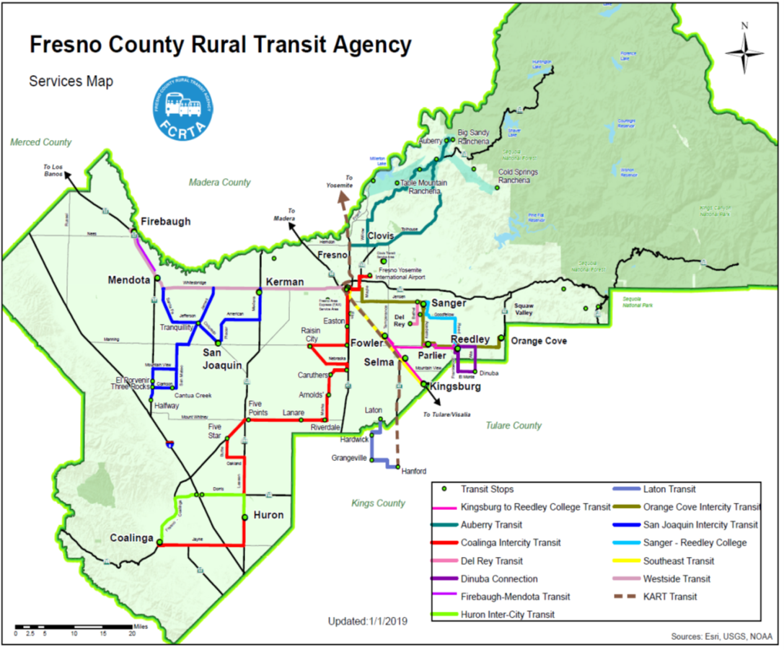

HEAD WAYS AND PERIODS OF OPERATION
Fresno County Rural Transit Agency (FCRTA) – Currently, the FCRTA has 20 transit subsystems that are generally available Monday through Friday from 7:00 a.m. to 5:30 p.m. FCRTA’s transit services continue to be available to those within each of the thirteen rural incorporated cities of Fresno County – Coalinga, Firebaugh, Fowler, Huron, Kerman, Kingsburg, Mendota, Orange Cove, Parlier, Reedley, Sanger, San Joaquin, and Selma. Many unincorporated rural communities are also being served, including the following: Alder Springs, Auberry, Burrough Valley, Cantua Creek, Caruthers, Del Rey, Easton, El Porvenir, Five Points, Friant, Halfway, Jose Basin, Lanare, Laton, Marshall Station, Meadow Lakes, Mile High, New Auberry, O’Neill’s, Prather, Raisin City, Riverdale, Sycamore, Three Rocks, Tollhouse, Tranquility, and the American Indian Rancherias of Big Sandy, Cold Springs and Table Mountain. Limited service to neighboring counties Avenal, Grangeville, Hanford and Hardwick in Kings County.

Using scheduled, fixed route services: With scheduled, fixed route services, a patron may also call a local phone number to determine the nearest designated bus stop to their location, and the scheduled time to board the transit vehicle for a trip to the desired location along the route.

Service between rural cities and the Fresno-Clovis Metropolitan Area are provided on a scheduled, fixed route basis. The inter-city and regional common carrier services of Greyhound and Orange Belt Stages have been reduced or eliminated to a number of rural cities in recent years.

FCRTA Subsystems (In-City and Inter-City)
- Auberry Transit – 1-855-612-5184 – Call for reservations
Local service between foothill communities and the Indian Rancherias of Big Sandy and Cold Springs, 8:00 a.m – 2:30 p.m. , Mon-Fri. Inter-City services to the Fresno-Clovis Area
8 am – 5 pm on Tuesdays
- Coalinga Transit – 935-1511 – Call for reservations
Local service Mon-Fri 8:30 a.m – 4:15 p.m.
- Coalinga Transit Intercity Service – 935-1511
Service to the Fresno-Clovis Area, Mon – Sat 8:00 a.m – 5:45 pm.
- Del Rey Transit – 1-855-612-5184 – Call for reservations
Local service from 8:00 a.m – 5:00 p.m. Mon. – Fri.
Saturday 10:00 a.m. – 3:00 p.m.
- Firebaugh Transit – 1-855-612-5184 – Call for reservations
Local service from 7:00 a.m – 4:00 p.m. Mon-Fri.
- Firebaugh-Mendota Transit - 1-855-612-5184 – Call for reservations
Service between Firebaugh and Mendota 7:00 a.m – 5:00 p.m. Mon-Fri.
- Fowler Transit – 1-855-612-5184 – Call for reservations
Local service from 7:00 a.m – 3:00 p.m. Mon-Fri.
- Huron Transit – 1-855-612-5184 – Call for reservations
Local service from 7:00 a.m – 4:30 p.m. Mon-Fri.
- Huron Inter-City Transit – 1-855-612-5184 – Call for reservations but not required
Service between Coalinga and Huron 8:30 a.m – 5:15 p.m. Mon-Fri.
- Kerman Transit – 1-855-612-5184 – Call for reservations
Local service from 7:00 a.m – 4:00 p.m. Mon-Fri.
- Kingsburg Transit – 1-855-612-5184 – Call for reservations
Local service from 7:00 a.m – 5:30 p.m. Mon-Fri., 8:00 a.m -5:00 p.m on Sat.
- Laton Transit – 852-2717 – Call for reservations
Service between Laton and Kings County Communities of Hardwick, Grangeville and Hanford. 10:00 a.m. – 2:00 p.m. Mon-Fri.
- Hanford-Fresno Transit – 852-2717 or 1-800-675-8881. Service provided by Kings Area Rural Transit from Hanford to Fresno for medical appointments only. Mon., Wed., Fri. for $3.00, senior tokens not accepted.
- Mendota Transit – 1-855-612-5184 – Call for reservations
Local service provided from 7:00 a.m – 5:00 p.m. Mon-Fri.
- Orange Cove Transit – 1-855-612-5184 – Call for reservations
Local service provided from 7:00 a.m – 5:30 p.m. Mon-Fri.
- Orange Cove Inter-City – 1-855-612-5184 – Call for reservation but not required
Service between Orange Cove, Reedley, Parlier, Sanger & Fresno 7:00 a.m-5:30 pm on a fixed route, Mon-Fri.
- Parlier Transit – 1-855-612-5184 – Call for reservations
Local service provided from 7:00 a.m – 4:00 p.m. Mon-Fri.
- Reedley Transit – 1-855-612-5184– Call for reservations
Local service provided from 8:00 a.m – 5:00 p.m. Mon-Fri. and 8:00 am – 5:00 p.m. on Sat
- Rural Transit – 1-855-612-5184 – Call for reservations
Demand Response Service in unincorporated rural areas 8:00 a.m. – 5:00 p.m. Mon-Fri.
- Sanger Transit – 1-855-612-5184 – Call for reservations
Local service provided from 7:00 a.m – 4:30 p.m. Mon-Fri and 8:00 am – 5:00 p.m. on Sat
- Sanger Express – 1-855-612-5184 – Call for reservations but not required
Service from Sanger to Reedley 6:45 a.m – 4:05 p.m. Mon-Fri.
- San Joaquin Transit – 1-855-612-5184 – Call for reservations but not required
Service from San Joaquin to Tranquillity, Cantua Creek, Halfway, El Porvenir, and Three Rocks provided from 7:00 a.m – 5:30 p.m. Mon-Fri.,
- Selma Transit – 1-855-612-5184 – Call for reservations
Local service provided from 7:00 a.m – 5:30 p.m. Mon-Fri., 8:00 am -5:00 p.m on Sat
- Southeast Transit – 1-855-612-5184 – Call for reservation but not required
Service from Kingsburg to Selma, Fowler and Fresno between 7:00 a.m-5:30 pm, Mon-Fri.
- Westside Transit – 1-855-612-5184 – Call in for reservation if possible but not required
Service from Firebaugh to Mendota, Kerman and Fresno between 7:00 a.m-5:30 pm, Mon-Fri.
- Kingsburg - Reedley College Transit – 1-855-612-5184 – Call in for reservation if possible but not required. Service from Kingsburg to Reedley 6:45 a.m-4:00 p.m. Mon-Fri.

ON-TIME PERFORMANCE STANDARDS
Local: Ninety (90%) percent of all fixed-route trips and eighty (80%) percent of all deviated fixed-route trips should be operated "on-time," defined as not early, and no more than five (5) minutes late in comparison to the established time points.
Inter-City: Ninety (90%) percent of all trips should be operated "on-time," defined as not early, and no more than five (5) minutes late in comparison to the established time points.

The above On-time Performance definitions are based upon those definitions as found in the Fresno County 2026-2030 Short Range Transit Plan, June 26, 2025.
Local Fixed Route: 90%
Local Fixed Route (Deviated): 80%
Rural Fixed Route: 90%
Demand Response: 95%
Inter-City: 90%

SERVICE AVAILABILITY
It is the goal to provide transit service to residential areas, major medical, shopping, government, employment centers, and activity centers that can support those route services. The local route system will continue to be designed such that 85 percent of the population cluster areas is within one-fourth (1/4) mile of a fixed route or within the service area of a deviated fixed route or general public Dial-A-Ride service.

For Intra-county transit services, the goal is to provide transit service to those employment centers that can support commuter service consistent with the service efficiency and effectiveness goals of Fresno County Rural Transit Agency.

Vehicle Assignment
All vehicles within the Fresno County Rural Transit Agency fleet are lift-equipped, have bicycle racks and heat/air conditioning. Vehicles are assigned based on operating characteristics of the routes. Bus assignments take into account the operating characteristics of the bus and route. In-City routes typically operate smaller more maneuverable cut-away type buses while Inter-City routes typically operate 22-40 foot transit buses to accommodate long distance travel and larger passenger loads. Typically newer buses are assigned to Inter-City routes due to the distance traveled and response time to resolve mechanical issues.

FIXED ROUTE TRANSIT REQUIREMENTS
In accordance with 49 CFR 21.9 and guidance provided in FTA Circular 4702.1B Chapter IV, service standards and policies are required for fixed route services, and are optional for demand response services. Transit providers that operate 50 or more fixed route vehicles in peak service and are located in a UZA of 200,000 or more in population are required to provide additional demographic and service data; however, FCRTA does not meet this threshold as it does not operate 50 or more fixed route vehicles in peak service.

Attachment G

FRESNO COUNTY RURAL TRANSIT AUTHORITY (FCRTA)

3-Requirements to Set System-wide Service Policies
- Distribution of Transit Amenities
- Seating
- Bus Shelters
- Waste receptacles
- Passenger Information (Printed Signs, system maps, route maps, and schedules)

FCRTA does not possess any transit amenities related to rail service (rail stations, rail shelters, rail platform canopies, digital equipment/signs, escalators, or elevators) as FCRTA does not operate or provide any rail service nor does FCRTA own, operate or provide any rail facilities. FCRTA also does not own/operate any park and ride lots or similar amenities. As such, FCRTA does not have a policy for the distribution of such amenities.

Distribution of Transit Amenities
FCRTA strives to provide transit amenities where needed. Amenities may include seating such as benches, covered bus stop shelters, waste receptacles, and passenger information (printed signs, route maps, schedules).

Installation of transit amenities are based primarily on passenger boarding’s along the routes. Typically for local or Inter-City routes; amenities should be installed where passenger boarding’s number 5 or more persons (benches) and 10 or more persons (shelters).

Selection of bus stops to receive amenities is also be based on reports from drivers, call from riders, comments received in the Unmet Transit Needs process, and review of the FCRTA transit system by FCRTA staff. The determination of how bus stops are improved is limited by financial resources, cost effectiveness, site specific considerations, and accessibility to persons with disabilities, vehicle operating safety, and passenger volume.

SEATING
FCRTA prefers to use bus shelters as the primary form of seating at bus stops, benches are used infrequently. FCRTA will only place a bench at low passenger demand bus stops where adjacent seating is not available or in bus stop locations that would normally justify a bus shelter but the bus shelter cannot be installed due to accessibility or safety reasons. In most cases where a bench is installed at a bus stop, the City in which the bus stop is located typically provides the bench instead of FCRTA.

BUS SHELTERS
It is the policy of FCRTA to place bus shelters at high demand bus stops. FRCTA uses historic bus stop passenger count data to determine the most used bus stops. FCRTA has plans to have bus shelters installed at all of its high demand bus stops, a process that is still ongoing.

WASTE RECEPTACLES
FCRTA only places waste receptacles at bus stops that have bus shelters and are adjacent to commercial areas that have high pedestrian volumes throughout the day. However, in most cases, the City in which the bus stop is located typically provides the waste receptacles instead of FCRTA.

PASSENGER INFORMATION
FCRTA strives to provide passenger information (printed Signs, system maps, route maps, and schedules) where needed and in a variety of ways. FCRTA general transit information, regional transportation information, transit guides, a system map, transit fares information, and bus schedules are available on the FCRTA website at www.ruraltransit.org

During FY 2017-18 FCRTA significantly updated its website but still adds passenger information content to the FCRTA website frequently. FCRTA’s plans for new passenger information to be added its website include bus route maps, and more Spanish language translations of bus schedules, bus route maps, transit fares information, and passenger rules.

FCRTA also provides transit information on all of its vehicles in the form of printed signs, informational flyers, announcements, and schedules. All FCRTA bus shelters have attached metal signs that show the bus schedule for that bus route. At bus stops where there is no shelter FCRTA provides metal bus stop signs that show the bus schedule for that bus route. When and where needed, depending upon the circumstances, FCRTA will also mail pertinent transit information to the various communities where FCRTA transit service operates.

Attachment H

FCRTA EQUITY
ANALYSIS FOR NEW
BUS MAINTENANCE
FACILTY

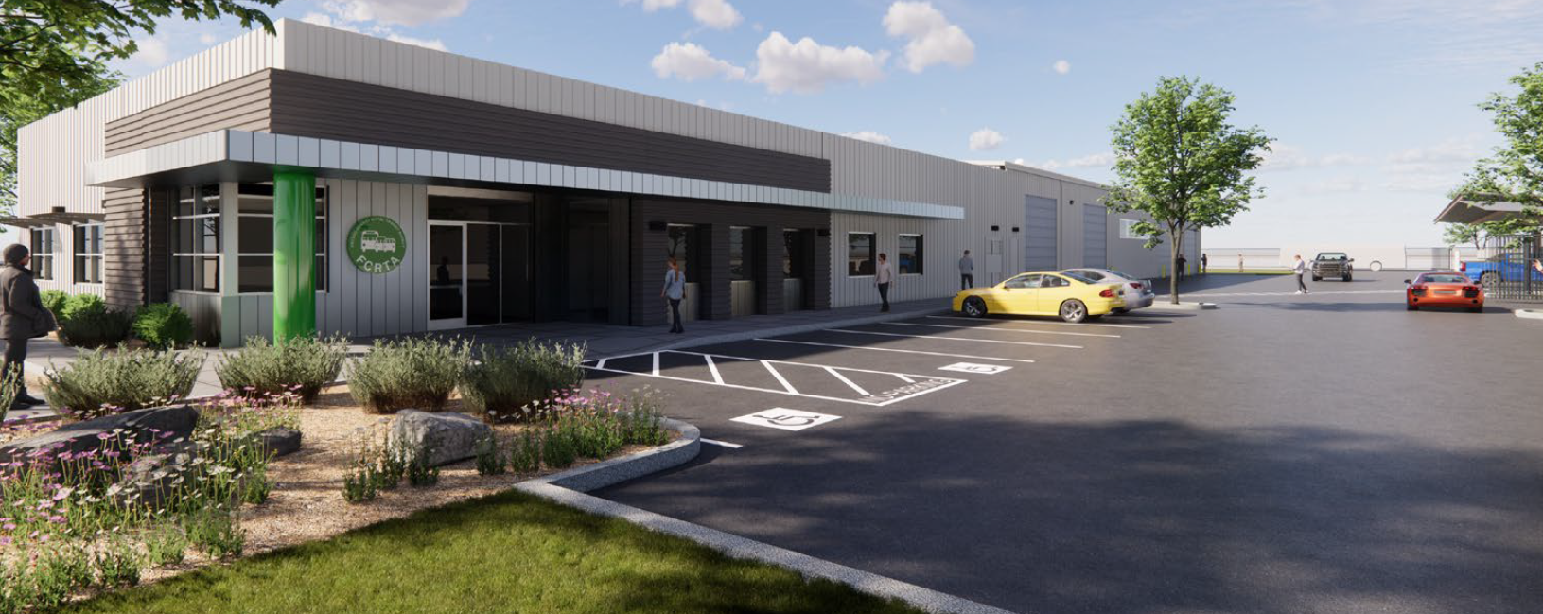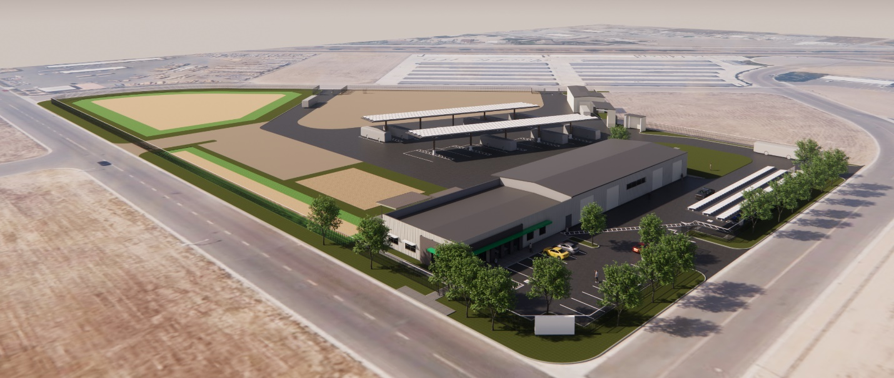
FCRTA Equity Analysis for New Bus Maintenance Facility

1-Executive Summary

Prior to constructing new facilities, recipients of federal transportation funding must consider how the location of a proposed facility may impact the affected minority and low-income community. While the impacts of constructing and operating a facility need to be environmentally analyzed for potential impacts, the selection of the site location must also be scrutinized to ensure that the site was selected in a non-discriminatory manner.

As required by Title VI of Civil Rights Act of 1964, Fresno County Rural Transit Agency (FCRTA) has conducted an Equity Analysis intended to ensure that the location of the planned new Bus Maintenance Facility was selected without regard to race, color, or national origin. In addition, as required under Executive Order 12898 Federal Actions to Address Environmental Justice in Minority Populations and Low-Income Populations, staff has completed a parallel review to ensure minority and low-income populations are not disproportionately affected by the selection of the preferred site.

Along with data and studies undertaken as part of the environmental review process, FCRTA has determined that the selection of the proposed Bus Maintenance Facility site at 1821 Pacific Avenue in Selma would not result in a disparate impact to minority or low-income populations.

2-Background

TITLE VI AND ENVIRONMENTAL JUSTICE REQUIREMENTS

Under Title VI of the Civil Rights Act of 1964, no person in the United States shall, on the ground of race, color, or national origin, be excluded from participation in, be denied the benefits of, or be subjected to discrimination under any program or activity receiving Federal financial assistance. As a recipient of federal funds, the RTA is required to conduct a Fixed Facility Equity
Analysis, highlighted in both the federal Title VI guidance1 and under Title 49 of the Code of
Federal Regulation2 that is intended to ensure that the location is selected without regard to race, color, or national origin. This analysis must also “give attention to other facilities with
similar impacts in the area to determine if any cumulative adverse impacts might result.”

In addition, Executive Order 128983 Federal Actions to Address Environmental Justice in
Minority Populations and Low-Income Populations requires DOT recipients to undertake analyses to ensure adverse impacts do not disproportionately impact minority and low-income communities. It should be stressed that disproportionately high and adverse effects, not population size, are the basis for environmental justice. While the minority or low-income population in an area may be small, this does not eliminate the possibility of a disproportionately high and adverse effect of a proposed action. Also, the environmental review completed to identify and address impacts/mitigations under the California Environmental Quality Act (CEQA) and National Environmental Protection Act (NEPA) were an important element of this evaluation.

POLICIES

FCRTA has developed policies and procedures to satisfy all requirements established by
federal guidance under FTA Circulars C4702.1B and 4703.1. FCRTA’s polices were established so that no person would be excluded from participation in, be denied the benefits of, or be subjected to discrimination under any program or activity provided by FCRTA. The policies also provide for meaningful access to programs for persons with Limited English Proficiency (LEP). FCRTA provides public notice of its policy to uphold and assure full compliance with Title VI on its agency website as follows: https://www.ruraltransit.org/documents/TitleVIProgram

Information regarding the FCRTA’s Title VI policies and the procedures for filing civil rights complaints are provided in English and Spanish.

PROJECT CONTEXT

FCRTA is a Joint Powers Authority created by a Joint Powers Agreement with the Fresno County of Fresno and the 13 incorporated Cities of Coalinga, Firebaugh, Fowler, Huron, Kerman, Kingsburg, Mendota, Orange Cove, Parlier, Reedley, Sanger, San Joaquin and Selma. Pursuant to section 6500 et seq. of the California Government Code, a Joint Powers Authority is established when two or more public agencies by agreement jointly exercise any power common to the contracting agencies. The purpose of the Joint Powers Agreement is to enable FCRTA to exercise the common powers of the member agencies to own, operate, and administer a county-wide public transportation system within the boundaries and over the territory within the jurisdiction of the Joint Powers Authority. Specifically, FCRTA manages inter-city route and in-city paratransit services throughout rural Fresno County and is contracted by MV Transportation to operate and provide services in the 13 incorporated Cities and various unincorporated communities of Fresno County.

In 2018 FCRTA decided that a new Maintenance facility was needed to replace its existing facility that was over 30 years old. On January 25, 2018, the FCRTA Board approved the submittal of a grant application for a State of Good Repair Program grant which was the first of several grants to raise the necessary funds to construct a new Maintenance facility.

On March 29, 2018, the FCRTA Board authorized FCRTA staff to pursue and acquire land for a future maintenance facility. Potential sites for the new Maintenance facility were empty parcels of land either adjacent to or nearby Golden State Boulevard in the Cities of Fowler, Selma, and Kingsburg. The potential sites became known as the Fowler site, the Selma site, and the Kingsburg site.

SITE SELECTION

During the site search process, FCRTA staff developed criteria for an acceptable Maintenance site. The criteria is as follows:
Be located within the County of Fresno.
Be located nearby where FCRTA transit services begin and end revenue service.
Be located in or nearby an existing Industrial area with existing infrastructure for industrial uses such as roads, telephone, internet, radio, water, electric, and sewer service, or easy access to the infrastructure.
Be affordable within an existing Industrial Park or Industrially Zoned land if no sites are located in an Industrial Park.
Be in an area that is relatively centrally located to nearby major service areas and/or transit vehicle storage areas.
Be large enough to support development of required transit facilities (at least 5 acres).
Be in or nearby an area of similar land uses (industrial or commercial).
Be located nearby by a major Highway or Freeway.
Preferably have the site be owned by a City, County, School District, or similar public entity.

The sites in Fowler, Selma, and Kingsburg were reviewed by FCRTA staff in conjunction with local officials in these three Cities. The following findings were made during the review of the three sites:

All three sites were confirmed to be within the County of Fresno

All three sites were determined to be nearby where FCRTA transit services begin and end revenue service.

Only the Selma site was in an Industrial area with existing infrastructure for industrial uses.

Only the Selma site was located in an existing Industrial Park.

The Selma site was judged to be the most centrally located of the three proposed sites.

All three sites were large enough to support development of required transit facilities.

Only the Selma site was in an area of similar land uses (industrial).

All three sites were located nearby by a major Highway or Freeway.

Only the Selma site was owned by a City or similar public entity.

As a result of these findings the Selma site was chosen as the preferred site for the new Maintenance facility.
SITE SELECTION APPROVAL

At its April 26, 2018, Board meeting, the FCRTA board designated the Selma site as the preferred site for the new maintenance facility. The Cities of Fowler, Selma, and Kingsburg all submitted letters of interest to FCRTA to have their sites reviewed and considered. FCRTA staff reviewed each site and determined the recommended site would be the Selma site. Reasons for choosing this site were several. The Selma site was the most centralized of the three as this site was in between the more northerly located Fowler site and the more southerly located Kingsburg site. Also, the land for the Selma site is owned by the City of Selma and it was the most affordable of the three sites. Finally, the Selma site was located with an existing Industrial Park that makes use of existing road, sewer, water, and electrical infrastructure in the area.

ENVIRONMENTAL REVIEW/NEPA ACTIVITIES

The preferred site at 1821 Pacific Avenue is associated with an Initial Study (or Environmental Site Assessment) by Krazan & Associates in June 2018, and a Categorical Exemption (Environmental Determination) study by LSA in 2020. The Notice of Exemption was approved by the FCRTA Board of Directors on July 26, 2018. On July 30, 2020, the FCRTA Board of Directors approved of LSA’s study findings pursuant to the National Environmental Policy Act (NEPA) and also approved FCRTA’s request of a NEPA Categorical Exclusion and authorized FCRTA filing a Notice of Determination.

3-Project Description

FCRTA is constructing a new maintenance facility known as the Selma Maintenance Facility Project which consists of developing a 7.5-acre vacant in Selma California for dispatch and vehicle maintenance operations that serve rural Fresno County and accommodate future transit needs. The project is planned to begin construction in 2023.

The facility will include approximately 9,800 square feet of maintenance shop space equipped to service both natural gas and electric transit buses and 40-foot battery electric buses, light-duty electric vehicles and vans. Also included is a 4,900 square foot office building split evenly between a centralized dispatching and supervisor’s offices and a training facility for technician training in advanced transit vehicle technology (electric and solar). Also included is a bus wash capable of washing up to 40-foot transit buses that would apply conservation and operations best practices such as on-site recycled water, a reverse osmosis final rinse water system, and bus air dryers. A wash pad with a canopy for handwashing cars and vans will also be installed along with a tire storage and canopy, and a new covered hazardous material storage with concrete curb containment.

The project will require the installation of electric vehicle (EV) chargers to serve BEBs. One (1) charger will be inductive, two (2) BYD Depot chargers, and twenty-nine (29) Level 2 EV chargers will serve electric transit vans and vehicles located under solar carports. The project will require the construction of 3 bus ports with solar roofs for parking for vehicles ranging in size from cars to 40ft transit buses. Also, the project will feature a Solar Field for its energy management system. The project will also require the installation of approximately 1.3 to 2.0 megawatts (MW) of on-site solar power and a minimum of 500 kilowatt-hours (kWh) of battery storage to support electric vehicle charging.

PREFERRED SITE LOCATION

The project site is located at 1821 Pacific Avenue in the City of Selma, California. The project site is bound to the north by Valley View Avenue, to the east by Pacific Avenue, and to the south and west by Tucker Avenue. Refer to Figure 1, Regional Location. The project site is comprised of four parcels and includes the following Assessor’s Parcel Numbers (APNs): 390-190-14S, 390-190-15S, 390-190-16S, and 390-190,-17S. FCRTA currently owns APNs 390-190-15S, 390-190-16S, and 390-190,-17S. FCRTA may purchase APN 390-190-14S in the future; as such, this parcel is evaluated in this CE. All four parcels currently consist of vacant land. APN 390-
190-15S was previously occupied by the Selma Fire Department’s training facility, which has since been relocated.

The City of Selma (City) General Plan Land Use and Zoning Maps designate the project site as Light Industrial and Light Manufacturing (M-1), respectively. In addition, adjacent properties are also designated Light Industrial and zoned M-1. The proposed maintenance and operations facility would be consistent with the Light Industrial designation and M-1 zone. There is also a school bus maintenance facility located directly across the street that is operated by Selma Unified School District.

Existing uses surrounding the site include the following:

West: The adjacent land to the west and northwest of the project site is vacant land with an industrial business being located beyond this land to the west. This area has a General Plan designation of Light Industrial and is zoned Light Manufacturing M-1.

North: To the north there is a school bus maintenance facility located directly across the street that is operated by Selma Unified School District. This area has a General Plan designation of Light Industrial and is zoned Light Manufacturing M-1.

East: To the east of the project site is vacant land within 1/8 of a mile of the site and then storage buildings beyond that distance. This area has a General Plan designation of Light Industrial and is zoned Light Manufacturing M-1.

South: To the south there is a mini storage facility located across the street from the project site.
This area has a General Plan designation of Light Industrial and is zoned Light Manufacturing M-1.
4- Public Outreach and Agency Coordination

On July 26, 2018, the FCRTA Board adopted Resolution No. 2018-14, on January 31, 2019, the FCRTA adopted Resolution No. 2019-01, and on December 11, 2019, the FCRTA adopted Resolution No. 2019-13. These resolutions included finding the approval of purchase and sale agreement and authorization of General Manager to execute related contracts to be Categorically Exempt from CEQA, and approving purchase and sale agreement and authorization of General Manager to execute related contracts associated with the FCRTA Maintenance and Operations Facility Project. The FCRTA has conducted public meetings and notices on a local level. In addition, all CEQA Categorical Exemptions have been approved by the FCRTA during public Board Meetings and have been posted on the FCRTA’s website. On July 20, 2020, the FCRTA Board adopted Resolution No. 2020-14 which approved the consultant LSA’s study findings pursuant to the National Environmental Policy Act (NEPA) and also approved FCRTA’s request of a NEPA Categorical Exclusion and authorized FCRTA filing a Notice of Determination.
On October 5, 2020, the FTA determined that the proposed project qualifies as a Categorical Exclusion under 23 CFR Part 771.118(d). FTA’s determination letter is included below.

This new Maintenance and Operations Facility was completed and opened in August 2025.

U.S. Department REGION IX 90 7th Street 888 South Figueroa Street
of Transportation Arizona, California, Suite 15-300 Suite 440
Federal Transit Hawaii, Nevada, Guam San Francisco, CA 94103-6701 Los Angeles, CA 90017-5467
Administration American Samoa, 415-734-9490 213-202-3950
Northern Mariana Islands

October 5, 2020

Mr. Moses Stites
General Manager
Fresno County Rural Transit Agency
2035 Tulare St, Suite 201
Fresno, CA 93712

Re: NEPA Categorical Exclusion Request: Fresno
County Rural Transit Agency Operation and
Maintenance Facility

Dear Mr. Stites:

The Federal Transit Administration (FTA) has completed its review of your request and
supporting documentation submitted on July 31, 2020 requesting an environmental
determination for Fresno County Rural Transit Agency Operations and Maintenance Facility
project. The Project will total approximately 14,700 square feet of development in the City of
Selma in Fresno County, California. The 9.14-acre site is located in an industrial area. The site
was previously developed but is not currently used.

Based on the information provided, FTA has determined that the project qualifies as a
categorical exclusion under 23 CFR Part 771.118(d), specifically:

“Additional actions that meet the criteria for a CE in the CEQ regulations (40 CFR 1508.4) and
paragraph (a) of this section may be designated as CEs only after FTA approval. The applicant must
submit documentation that demonstrates that the specific conditions or criteria for these CEs are satisfied and that significant environmental effects will not result.”

This review, which is based on past experience with similar projects, finds that the project: does not induce significant environmental impacts to planned growth or land use for the area; does not require the relocation of significant numbers of people; does not have a significant impact on
natural, cultural, recreational, historical or other resource; does not involve significant air, noise,
or water quality impacts; does not have significant impacts on travel patterns; and does not otherwise, either individually or cumulatively, have any significant environmental impact.

FTA reminds project sponsors of guidance concerning Categorical Exclusions (CEs). In
particular, FTA strongly encourages grant applicants to contact the Regional Office before exercising pre-award authority for project where it believes a CE under 23 CFR 771.118 (d)
applies. This reduces the risk of a grantee inappropriately exercising pre-award authority for
projects resulting in loss of eligibility for reimbursement of costs.

If you have any questions about this review, please contact Mr. Ted Matley, Director of Planning
and Program Development, at (415) 734-9468, or by email at ted.matley@dot.gov.

Sincerely,

RAYMOND S TELLIS

Ray Tellis
Regional Administrator

5-Analysis of Adverse Impacts & Effects on Minority and Low-Income Populations

As referenced in the October 2020 Environmental Determination (Categorical Exemption) by LSA and the June 2018 Environmental Site Assessment (Initial Study) by Krazan & Associates, the preferred 1821 Pacific Avenue location has been analyzed for impacts in the following 18 areas required under CEQA:

1. Aesthetics
2. Agricultural & Wetlands Resources
3. Air Quality
4. Biological & Resources
5. Historical & Cultural Resources
6. Geology & Soils
7. Greenhouse Gas Emissions
8. Hazards & Hazardous Materials
9. Hydrology & Water Quality
10. Land Use Planning
11. Mineral Resources
12. Noise
13. Population & Housing
14. Public Services
15. Transportation (Traffic & Parking)
16. Tribal Cultural Resources
17. Utility & Service Systems
18. Mandatory Findings of Significance

FCRTA submitted a request for a Categorical Exclusion (CE) to the FTA Region 9 office on July 31, 2020. The FTA provided a concurrence letter on October 5, 2020.

The conclusion under both CEQA and NEPA analyses is that the proposed project does not induce significant environmental impacts to planned growth or land use for the area; does not require the relocation of significant numbers of people; does not have a significant impact on
natural, cultural, recreational, historical or other resource; does not involve significant air, noise,
or water quality impacts; does not have significant impacts on travel patterns; and does not otherwise, either individually or cumulatively, have any significant environmental impact.

For the purposes of environmental justice analysis, federal agencies are required to identify whether a proposed project will possibly have disproportionately high and adverse effects on
minority or low-income populations within the proposed project vicinity. The proposed project
vicinity, or the affected environment for the environmental justice analysis, consists of the
proposed project site. For the purposes on this analysis, an impact is considered to be significant and require mitigation if it would result in any of the following:

Impact 1. Substantially affect employment, industry, or commerce, including requiring the
displacement of businesses or farms.

Impact 2. Substantially affect property values or the local tax base.

Impact 3. Substantially, disproportionately affect minority, low-income, elderly, disabled,
transit-dependent, or other specific interest group(s); or

Impact 4. Displace substantial numbers of people, necessitating the construction of
replacement housing elsewhere.

Based on all four of these impact areas, the proposed project will not result in any adverse
socioeconomic and environmental justice effects. Additionally, the proposed project would
have a beneficial effect to the minority communities in the project vicinity by providing additional employment opportunities.

EQUITY ANALYSIS

Although the project is deemed to have no significant adverse impact to the environment, it is important to further determine if minority and low-income populations are disproportionately affected by the selection of the preferred site for the new Maintenance facility. To determine the presence of minority and low-income populations near the two alternative sites, FCRTA compiled information at both the 2020 U.S. Census block group level and census tract level. A block group is a cluster of census blocks, and generally have populations between 600 and 3,000 people; a census tract is a cluster of block groups with populations generally between 1,500 and 8,000 people. However, if too few sample cases are reported at the block group level, then that data is not available. This was the case when attempting to evaluate populations living below poverty at the block group level. So, all of the data presented for the two alternative sites reflects census tract information. FCRTA also presents statewide, county and city data for comparison.

Upon investigation, it was observed that that there were very few residences within 1000 feet of the three proposed sites. Only the Selma site has a significant cluster of residences within 1000 feet of that site. This necessitated a more statistical analysis of the areas nearby the three proposed sites for comparison purposes.

As shown in Table below, the population in poverty in the census tract that includes the
preferred site at 1821 Pacific Avenue (15.1%) is below the entire City of Selma (23.4%),
and it is also below the countywide proportion (19.5%). The proportion is only slightly above the statewide percentage (12.3%). This shows that the proposed site falls within the range of local, regional, and state averages for poverty level.
The minority population percentages of two of the three proposed site locations are higher than either the County of Fresno as a whole and the statewide percentage. The minority population percentages of two of the three proposed site locations are slightly above and below the Citywide percentages for the sites in Selma and Fowler which make these sites very representative of their Cities.

Poverty and Minority Populations Near Potential Sites
Location | Population  in Poverty | Poverty  Percentage | Minority  Population | Minority  Percentage
Preferred Site: 1821 Pacific (Census Tract BG 1 70.04) | 860 | 15.1% | 3,989 | 70.0%
Alt Site 1: South/Golden State (Census Tract 16-Fowler) | 1,236 | 22.4% | 3,754 | 68.0%
Alt Site 2: Kamm/Golden State (Census Tract B4 3 72.04-Kings.) | 138 | 5.1% | 462 | 17.0%
City of Selma | 5,716 | 23.4% | 20,716 | 84.8%
City of Fowler | 1,459 | 20.4% | 4,793 | 67.0%
City of Kingsburg | 1,059 | 8.4% | 5,600 | 44.4%
County of Fresno | 197,962 | 19.5% | 555,308 | 54.7%
State of California | 4,800,609 | 12.3% | 15,689,795 | 40.2%
Source: 2020 Census

Of the three proposed sites, the preferred 1821 Pacific site in Selma has the highest minority population living within the Census Tract for the location of the proposed site. This is in line with the City of Selma having the largest minority population of the Cities of Selma, Fowler, and Kingsburg.

6-Conclusions

In accordance with both federal and state environmental law and federal guidance, the RTA has
conducted focused environmental impact evaluations for the proposed Bus Maintenance
Facility Project. This has included both technical studies and analyses associated with the
California Environmental Quality Act (CEQA) and the National Environmental Policy Act (NEPA), as well as a qualitative site selection evaluation and public review that is required by Title VI of the Civil Rights Act of 1964.
Based upon the analyses conducted, the proposed project would not result in significant impacts to the environment. Additionally, based on the qualitative site selection evaluation and
public review of the proposed sites, the site was chosen without regard to race, color or
national origin, nor are low-income communities disproportionately impacted.

APPENDIX A

FEDERAL TRANSIT ADMINISTRATION CIVIL RIGHTS ASSURANCE

The Fresno County Rural Transit Agency HEREBY CERTIFIES THAT, as a condition of receiving Federal financial assistance under the Urban Mass Transportation Act of 1964, as amended, it will ensure that:

- No person on the basis of race, color, or national origin will be subjected to discrimination in the level and quality of transportation services and transit-related benefits.

- The Fresno County Rural Transit Agency will compile, maintain, and submit in a timely
manner Title VI information required by FTA Circular 4702.1A and in compliance with the Department of Transportation's Title VI regulation, 49 CFR Part 21.9.

- The Fresno County Rural Transit Agency will make it known to the public that those
person or persons alleging discrimination on the basis of race, color, or national origin as it relates to the provision of transportation services and transit-related benefits may file a complaint with the Federal Transit Administration and/or the U.S. Department of Transportation.

The person or persons whose signature appears below are authorized to sign this assurance on behalf of the grant applicant or recipient.

Moses Stites, General Manager DATE: 06/29/2023
(NAME AND TITLE OF AUTHORIZED OFFICER)

____________________________________
(SIGNATURE OF AUTHORIZED OFFICER)
Date: June 29, 2023

FIA C 4702.1A
5-13-2007

APPENDIX B

DEPARTMENT OF TRANSPORTATION TITLE VI ASSURANCE

The Fresno County Rural Transit Agency (hereinafter referred to as the "Recipient") HEREBY AGREES THAT as a condition to receiving any Federal financial assistance from the Department of Transportation it will comply with Title VI of the Civil Rights Act of 1964, 78 Stat. 252, 42 U.S.C. 2000d-42 U.S.C. 2000d-4 (hereinafter referred to as the Act), and all requirements imposed by or pursuant to Title 49, Code of Federal Regulations, Department of Transportation, Subtitle A, Office of the Secretary, Part 21, Nondiscrimination in Federally assisted Programs of the Department of Transportation - Effectuation of Title VI of the Civil Rights Act of 1964 (hereinafter referred to as the Regulations) and other pertinent directives, to the end that in accordance with the Act, Regulations, and other pertinent directives, no person in the United States shall, on the grounds of race, color, or national origin, be excluded from participation in, be denied the benefits of, or be otherwise subjected to discrimination under any program or activity for which the Recipient receives Federal financial assistance from the Department of Transportation, including Federal Transit Administration, and HEREBY GIVES ASSURANCE THAT it will promptly take any measures necessary to effectuate this agreement. This assurance is required by subsection 21.7(a) of the Regulations.

More specifically and without limiting the above general assurance, the Recipient hereby gives the following specific assurances with respect to its FTA Section 5307, 5309, 5310, 5311, 5316, 5337 and 5339 Programs:

- That the Recipient agrees that each "program" and each "facility" as defined in
subsections 21.23(e) and 21.23(b) of the Regulations, will be (with regard to a "program") conducted, or will be (with regard to a "facility") operated in compliance with all requirements imposed by, or pursuant to, the Regulations.

- That the Recipient shall insert the following notification in all solicitations for bids for
work or material subject to the Regulations and made in connection with all FTA Section 5307, 5309, 5310, 5311, 5316, 5337 and 5339 Programs: and, in adapted form in all proposals for negotiated agreements:

The Fresno County Rural Transit Agency, in accordance with Title VI of the Civil Rights Act of 1964, 78 Stat. 252, 42 U.S.C. 2000d to 2000d-4 and Title 49, Code of Federal Regulations, Department of Transportation, Subtitle A, Office of the Secretary, Part 21, Nondiscrimination in Federally-Assisted Programs of the Department of Transportation issued pursuant to such Act, hereby notifies all bidders that it will affirmatively insure that in any contract entered into pursuant to this advertisement, minority business enterprises will be afforded full opportunity to submit bids in response to this invitation and will not be discriminated against on the grounds of race, color, or national origin in consideration for an award.

- That the Recipient shall insert the clauses of Appendix A of this assurance in every
contract subject to this Act and the Regulations.

- That the Recipient shall insert the clauses of Appendix B of this assurance, as a
covenant running with the land, in any deed from the United States affecting a transfer of real property, structures, or improvements thereon, or interest therein.

- That where the Recipient receives Federal financial assistance to construct a facility, or
part of a facility, the assurance shall extend to the entire facility and facilities operated in connection therewith.

- That where the Recipient receives Federal financial assistance in the form, or for the
acquisition of real property or an interest in real property, the assurance shall extend to rights to space on, over, or under such property.

- That the Recipient shall include the appropriate clauses set forth in Appendix C of this
assurance, as a covenant running with the land, in any future deeds, leases, permits, licenses, and similar agreements enter into by the Recipient with other parties: (a) for the subsequent transfer of real property acquired or improved under FTA Section 5307. 5309. 5310, 5311, 5316, 5337 and 5339 Programs; and (b) for the construction or use of or access to space on, over, or under real property acquired, or improved under FTA Section 5307, 5309, 5310, 5311, 5316, 5337 and 5339 Programs.

- That this assurance obligates the Recipient for the period during which Federal financial
assistance is extended to the program, except where the Federal financial assistance is to provide, or is in the form of, personal property, or real property or interest therein or structures or improvements thereon, in which case the assurance obligates the Recipient or any transferee for the longer of the following periods: (a) the period during which the property is used for a purpose for which the Federal financial assistance is extended, or for another purpose involving the provision of similar services or benefits; or (b) the period during which the Recipient retains ownership or possession of the property.

- The Recipient shall provide for such methods of administration for the program as are
found by the Secretary of Transportation or the official to whom they delegates specific authority to give reasonable guarantee that it, other recipients, subgrantees, contractors, subcontractors, transferees, successors in interest, and other participants of Federal financial assistance under such program will comply with all requirements imposed or pursuant to the Act, the Regulations and this assurance.

- The Recipient agrees that the United States has a right to seek judicial enforcement with
regard to any matter arising under the Act, the Regulations and this assurance.

FIA C 4702.1A
5-13-2007

THIS ASSURANCE is given in consideration of and for the purpose of obtaining any and all Federal grants, loans, contracts, property, discounts or other Federal financial assistance extended after the date hereof to the Recipient by the Department of Transportation under the FTA Section 5307, 5309, 5310, 5311, 5316, 5337 and 5339 Programs and is binding on it, other recipients, subgrantees, contractors, subcontractors, transferees, successors in interest and other participants in the FTA Section 5307, 5309, 5310, 5311, 5316. 5337 and 5339 Programs. The person or persons whose signatures appear below are authorized to sign this assurance on behalf of the Recipient.

DATED: 06/25/2026

by

Fresno County Rural Transit Agency
(Name of Recipient)

Janelle Del Campo, General Manager
(Name and Title of Authorized Officer)

______________________________
(Signature of Authorized Officer)

Attachments:
Appendices A, B, and C

FTA C 4702.1A
5-13-2007

(APPENDIX A TO TITLE VI ASSURANCE)

During the performance of this contract, the contractor, for itself, its assignees and successors in interest (hereinafter referred to as the "contractor") agrees as follows:
- Compliance with Regulations: The Contractor shall comply with the Regulations
relative to nondiscrimination in federally assisted programs of the Department of Transportation (hereinafter, "DOT") Title 49, Code of Federal Regulations, Part 21, as they may be amended from time to time, (hereinafter referred to as the Regulations), which are herein incorporated by reference and made a part of this contract.

- Nondiscrimination: The contractor, with regard to the work performed by it during the
contract, shall not discriminate on the grounds of race, color, or national origin in the selection and retention of subcontractors, including procurements of materials and leases of equipment. The contractor shall not participate either directly or indirectly in the discrimination prohibited by Section 21.5 of the Regulations, including employment practices when the contract covers a program set forth in Appendix B of the Regulations.

- Solicitations for Subcontracts, Including Procurements of Materials and Equipment: In
all solicitations either by competitive bidding or negotiation made by the contractor for work to be performed under a subcontract, including procurements of materials or leases of equipment, each potential subcontractor or supplier shall be notified by the contractor of the contractor's obligations under this contract and the Regulations relative to nondiscrimination on the grounds of race, color, or national origin.

- Information and Reports: The contractor shall provide all information and reports
required by the Regulations or directives issued pursuant thereto, and shall permit access to its books, records, accounts, other sources of information, and its facilities as may be determined by the or the Fresno County Rural Transit Agency to be pertinent to ascertain compliance with such Regulations, orders and instructions. Where any information required of a contractor is in the exclusive possession of another who fails or refuses to furnish this information the contractor shall so certify to the Fresno County Rural Transit Agency, or the Federal Transit Administration as appropriate, and shall set forth what efforts it has made to obtain the information.

- Sanctions for Noncompliance: In the event of the contractor's noncompliance with
nondiscrimination provisions of this contract, the Fresno County Rural Transit Agency
shall impose contract sanctions as it or they Federal Transit Administration may determine to be appropriate, including, but not limited to:
- withholding of payments to the contractor under the contract until the contractor
complies; and/or
- cancellation, termination, or suspension of the contract, in whole or in part

- Incorporation of Provisions: The contractor shall include the provisions of paragraphs (1)
through (6) in every subcontract, including procurements of materials and leases of equipment, unless exempt by the Regulations, or directives issued pursuant thereto. The contractor shall

take such action with respect to any subcontract or procurement as the Fresno County Rural Transit Agency or the Federal Transit Administration may direct as a means of enforcing such provisions including sanctions for noncompliance: Provided, however, that in the event a contractor becomes involved in, or is threatened with, litigation with a subcontractor or supplier as a result of such direction, the contractor may request the Fresno County Rural Transit Agency to enter into such litigation to protect the interests of the Fresno County Rural Transit Agency, and, in addition, the contractor may request the United States to enter into such litigation to protect the interests of the United States.

FTA C 4702.1A
5-13-2007

(APPENDIX B TO TITLE VI ASSURANCE)

The following clauses shall be included in any and all deeds affecting or recording the transfer of real property, structures or improvements thereon, or interest therein from the United States.

(GRANTING CLAUSE)

NOW, THEREFORE, the Department of Transportation, as authorized by law, and upon the condition that the Fresno County Rural Transit Agency will accept title to the lands and maintain the project constructed thereon, in accordance with Urban Mass Transit Act of 1964, the Regulations for the Administration of FTA Section 5307, 5309, 5310, 5311, 5316, 5337 and 5339 Programs and the policies and procedures prescribed by Federal Transit Administration of the Department of Transportation and, also in accordance with and in compliance with all requirements imposed by or pursuant to Title 49, Code of Federal Regulations, Department of Transportation, Subtitle A, Office of the Secretary, Part 21, Nondiscrimination in Federally-Assisted Programs of the Department of Transportation (hereinafter referred to as the Regulations) pertaining to and effectuating the provisions of Title VI of the Civil Rights Act of 1964 (78 Stat. 252; 42 U.S.C. 2000d to 2000d-4), does hereby remise, release, quitclaim and convey unto the Fresno County Transit Rural Transit Agency all the right, title and interest of the Department of Transportation in and to said lands described in Exhibit "A" attached hereto and made a part hereof.

(HABENDUM CLAUSE)

TO HAVE AND TO HOLD said lands and interests therein unto Fresno County Rural
Transit Agency and its successors forever, subject, however, to the covenants, conditions, restrictions and reservations herein contained as follows, which will remain in effect for the period during which the real property or structures are used for a purpose for which Federal financial assistance is extended or for another purpose involving the provision of similar services or benefits and shall be binding on the Fresno County Rural Transit Agency, its successors and assigns.

The Fresno County Rural Transit Agency, in consideration of the conveyance of said lands and interests in lands, does hereby covenant and agree as a covenant running with the land for itself, its successors and assigns, that (1) no person shall on the grounds of race, color, or national origin, be excluded from participation in, be

FTA C 4702.1A
5-13-2007

denied the benefits of, or be otherwise subjected to discrimination with regard to any facility located wholly or in part on, over or under such lands hereby conveyed (,) (and)* (2) that the Fresno County Rural Transit Agency shall use the lands and interests in lands and interests in lands so conveyed, in compliance with all requirements imposed by or pursuant to Title 49, Code of Federal Regulations, Department of Transportation, Subtitle A, Office of the Secretary, Part 21, Nondiscrimination in Federally-Assisted Programs of the Department of Transportation - Effectuation of Title VI of the Civil Rights Act of 1964, and as said Regulations may be amended, and (3) that in the event of breach of any of the above-mentioned nondiscrimination conditions, the Department shall have a right to re-enter said lands and facilities on said land, and the above described land and facilities shall thereon revert to and vest in and become the absolute property of the Department of Transportation and its assigns as such interest existed prior to this instruction.*

*Reverter clause and related language to be used only when it is determined that such a clause is necessary in order to effectuate the purposes of Title VI of the Civil Rights Act of 1964.

FTA C 4702.1A
5-13-2007

(APPENDIX C TO TITLE VI ASSURANCE)

The following clauses shall be included in all deeds, licenses, leases, permits, or similar instruments entered into by the Fresno County Rural Transit Agency pursuant to the provisions of Assurance 7(a).

The (grantee, licensee, lessee, permitee, etc., as appropriate) for herself/himself, his/her heirs, personal representatives, successors in interest, and assigns, as a part of the consideration hereof, does hereby covenant and agree [in the case of deeds and leases add "as a covenant running with the land") that in the event facilities are constructed, maintained, or otherwise operated on the said property described in this (deed, license, lease, permit, etc.) for a purpose for which a Department of Transportation program or activity is extended or for another purpose involving the provision of similar services or benefits, the (grantee, licensee lessee, permitee, etc.) shall maintain and operate such facilities and services in compliance with all other requirements imposed pursuant to Title 49, Code of Federal Regulations, Department of Transportation, Subtitle A, Office of the Secretary, Part 21, Nondiscrimination of Federally assisted Programs of the Department of Transportation - Effectuation of Title VI of the Civil Rights Act of 1964, and as said Regulations may be amended.

(Include in licenses, leases, permits, etc.)*

That in the event of breach of any of the above nondiscrimination covenants, Fresno County Rural Transit Agency shall have the right to terminate the (license, lease, permit, etc.) and to re-enter and repossess said land and the facilities thereon, and hold the same as if said (licenses, lease, permit, etc.) had never been made or issued.

(Include in deeds)*

That in the event of breach of any of the above nondiscrimination covenants, Fresno County Rural Transit Agency shall have the right to re-enter said lands and facilities thereon, and the above described lands and facilities shall thereupon revert to and vest in and become the absolute property of Fresno County Rural Transit Agency and its assigns.

FTA C 4702.1A
5-13-2007

The following shall be included in all deeds, licenses, leases, permits, or similar agreements entered into by Fresno County Rural Transit Agency pursuant to the provisions of Assurance 7(b).

The (grantee, licensee, lessee, permitee, etc., as appropriate) for herself/himself, his/her personal representatives, successors in interest, and assigns, as a part of the consideration hereof, does hereby covenant and agree (in case of deeds, and leases add "as a covenant running with the land") that (1) no person on the grounds of race, color, or national origin shall be excluded from participation in, be denied the benefits of, or be otherwise subjected to discrimination in the use of said facilities, (2) that in the construction of any improvements on, over or under such land and the furnishing services thereon, no person on the grounds of race, color, or national origin shall be excluded from the participation in, be denied the benefits of, or be otherwise subjected to discrimination, and (3) that the (grantee, licensee, lessee, permitee, etc.) shall use the premises in compliance with all other requirements imposed by or pursuant to Title 49, Code of Federal Regulations, Department of Transportation, Subtitle A, Office of the Secretary, Part 21, Nondiscrimination in Federally-Assisted Programs of the Department of Transportation - Effectuation of Title VI of the Civil Rights Act of 1964, and as said Regulations may be amended.

(Include in licenses, leases, permits, etc.)*

That in the event of breach of any of the above nondiscrimination covenants, Fresno County Rural Transit Agency shall have the right to terminate the (license, lease, permit, etc.) and to reenter and repossess said land and the facilities thereon, and hold the same as if said (license, lease, permit, etc.) had never been made or issued.

(Include in deeds)*

That in the event of breach of any of the above nondiscrimination covenants, Fresno County Rural Transit Agency shall have the right to re-enter said land and facilities thereon, and the above described lands and facilities shall thereupon revert to and vest in and become the absolute property of Fresno County Rural Transit Agency and its assigns.

*Reverter clause and related language to be used only when it is determined that
such a clause is necessary in order to effectuate the purpose of Title VI of the Civil Rights Act of 1964.

APPENDIX C

DIRECTORY
DEPARTMENT OF TRANSPORTATION AND
FEDERAL TRANSIT ADMINISTRATION OFFICES

Headquarters

Departmental Director of Civil Rights Director, Office of Civil Rights
Office of the Secretary Federal Transit Administration
Department of Transportation 400 Seventh Street, SW., Room 7412
400 Seventh Street, SW., Room 10215 Washington, D.C. 20590
Washington, D.C. 20590

AREA CIVIL RIGHTS
OFFICES EASTERN AREA
(Regions 1 and 2)

Federal Transit Administration Federal Transit Administration
Transportation Systems Center, Suite 920 One Bowling Green, Room 429
Kendall Square, 55 Broadway New York, NY 10004-1415
Cambridge, MA 02142-1093

SOUTHEASTER AREA
(Regions 3 and 4)

Federal Transit Administration Federal Transit Administration
1760 Market Street, Suite 500 Atlanta Federal Center, Suite 17T50
Philadelphia, PA 19103-4124 61 Forsyth Street, SW
Atlanta, GA 30303

CENTRAL/MID-WESTERN AREA
(Regions 5, 6, and 7)

Federal Transit Administration Federal Transit Administration Federal Transit Administration
200 W. Adams, Suite 320 819 Taylor Street, Room 8A36 901 Locust Street, Room 404
Chicago, IL 60606 Fort Worth, TX 76102 Kansas, MO 64106

WESTERN AREA
(Regions 8, 9, and 10)

Federal Transit Administration Federal Transit Administration Federal Transit Administration
12300 W. Dakota Ave., Suite 310 201 Mission Street, Suite 2210 915 Second Ave, Suite 33412
Lakewood, CO 80228-2583 San Francisco, CA 94105-1926 Seattle, WA 98174-1002
FTA C 4702.1A
5-13-2007

APPENDIX D

APPLICATION OF TITLE VI REQUIREMENTS TO FEDERAL FINANCIAL
ASSISTANCE OF THE FEDERAL TRANSIT ADMINISTRATION

Examples: Nondiscrimination on FTA Projects

The following examples, without being exhaustive, illustrate the application of the nondiscrimination provisions of this part to projects receiving Federal financial assistance under the programs of certain Department of Transportation operating administrations.

- Any person who is, or seeks to be, a patron of any public vehicle which is operated as a
part of, or in conjunction with, a project shall be given the same access, seating, and other treatment with regard to the use of such vehicle as other persons without regard to their race, color, or national origin.

- No person who is, or seeks, to be an employee of the project sponsor or lessees,
concessionaires, contractors, licensees, or any organization furnishing public transportation service as a part of, or in conjunction with, the project shall be treated less favorably than any other employee or applicant with regard to hiring, dismissal, advancement, wages, or any other conditions and benefits of employment, on the basis of race, color, or national origin.

- No person or group of persons shall be discriminated against with regard to the routing,
scheduling, or quality of transportation service furnished as a part of the project on the basis of race, color, or national origin. Frequency of service, age and quality of vehicles assigned to routes, quality of stations serving different routes, and location of routes may not be determined on the basis of race, color, or national origin.

- The location of projects requiring land acquisition and the displacement of persons from
their residences and businesses may not be determined on the basis of race, color, or national origin.

BEFORE THE
FRESNO COUNTY RURAL TRANSIT AGENCY
RESOLUTION NO. 2026-02

In the matter of: RESOLUTION ADOPTING THE FCRTA’S
Title VI Program UPDATED TITLE VI PROGRAM

WHEREAS, the Fresno County Rural Transit Agency (FCRTA) is a subrecipient of Federal Funds and has always, since its formation in 1979, been required to meet federal regulatory requirements pertaining to Title IV of the Civil Rights Act of 1964, as established by 49 CFR part 21.7; and

WHEREAS, the FCRTA has, and will continue to provide, annual “certifications and assurances” through the California Department of Transportation’s (Caltrans) Mass Transit Program, to the Federal Transit Administration as required in order to demonstrate its understanding, adherence and compliance with title VI of the Civil Right Act; and

WHEREAS, the FCRTA) continues to assure that no person or group of persons on the basis of race, color, or national origin, including limited English proficient persons, are never to be subject to discrimination in any form, at any level, or quality of its “open to the general public” transit service programs and provided activities, whether federally funded or not; and

WHEREAS, the FCRTA assures that all residents and visitors of the rural areas of Fresno County outside of the Fresno-Clovis Metropolitan Area are afforded meaningful access to our programs, activities and services; and

WHEREAS, the FCRTA updates its Title VI Program to meet the current refined emphasis to the Federal Transit Administration’s Guidelines and Requirements as they pertain to Title VI; and

THEREFORE, IT IS HEREBY RESOLVED, that the Fresno County Rural Transit Agency’s Board of Directors approves and adopts the updated FCRTA Title VI Program, following an expressed opportunity for public comment.

THE FOREGOING RESOLUTION was passed and adopted by the Fresno County Rural Transit Agency this 25th day of June, 2026.

AYES:

NOES:

ABSTAIN:

ABSENT:

Signed___________________________________
Victor Martinez, Chairman

I hereby certify that the foregoing is a true copy of a resolution of the
Fresno County Rural Transit Agency Duly adopted at a meeting thereof
Held on the 25th day of June, 2026.

Signed______________________________
Janelle Del Campo, General Manager

