Vehicle Description Sheet

All four buses are 2007 Bluebird Transit Buses with 37 seats, 2 wheelchair positions, 6 liter inline turbo engines, and new batteries. The CNG tanks for these buses may be expired based on their useful life.

Three out of the four buses are operational. The bus that isn’t operation is #111. This bus does not operate as it would crank up but not run. The engine for the bus is in great condition. This bus is missing a few parts.

Vehicle mileages: #111--129,526; #112--206,032; #113--173,831; #114--218,636 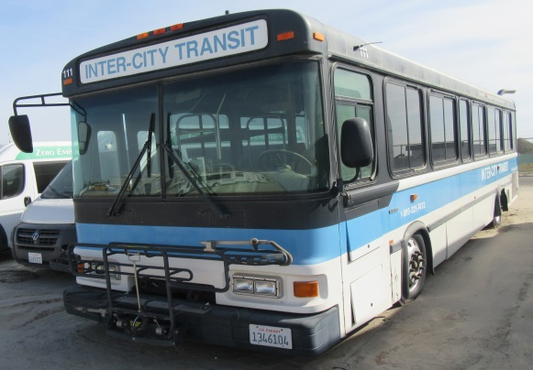 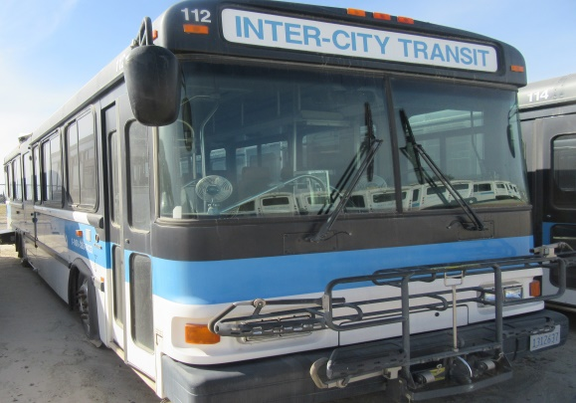 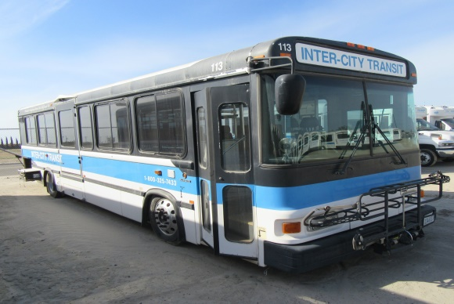 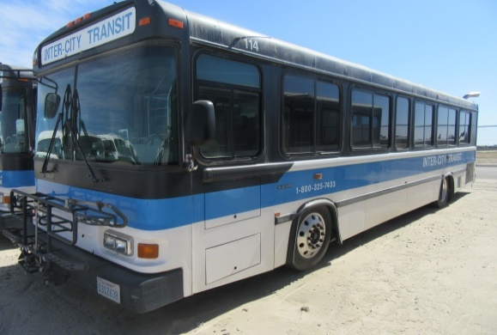
Bus #114
Bus #113
Bus #112
Bus #111
